**ERNET OF THINGS**





**University of Bridgeport**

By Abdel A Shakour

Soumil Nitin Shah (Graduate Assistant)

|  |  |  |  |
| --- | --- | --- | --- |
| **Sr No** | **Title** | **Lab** |  |
| **1** | **Lab 1**  **(Getting started with Raspberry Pi)** | **Lab 1A** | **Introduction to Raspberry pi** |
| **Lab 1B** | **Configuring GPIO as Output** |
| **Lab 1C** | **Pulse Width Modulation** |
| **Lab 1D** | **Introducing Tkinter with Raspberry pi** |
| **Lab 1E** | **Getting started with Sqlite3 and Raspberry Pi** |
| **Lab 1F** | **Configuring GPIO as input** |
| **2** | **Lab 2**  **[Interfacing Sensor’s]** | **Lab 2** | **Learn Interfacing Distance Sensor** |
| **Lab 2A** | **Learn to Log Sensor Data on Database** |
| **Lab 2B** | **Interfacing DHT-11/ DHT-22 Sensor with Raspberry Pi** |
| **Lab 2C** | **Objective Learn to Interface Camera Module** |
| **3** | **Lab 3**  **[Server-Client using socket]** | **Lab 3** | **Send Data from one Raspberry pi to another Raspberry Pi** |
| **4** | **Lab 4**  **[Cloud Platform’s]** | **Lab 4A** | **Uploading sensor Data on Thingspeak** |
| **Lab 4B** | **Getting Started with Twilio and Raspberry pi for SMS Notification** |
| **Lab 4C** | **Getting started with IFTTT** |
| **5** | **Lab 5**  **[Node-Red]** | **Lab 5A** | **Getting started with Node-red** |
| **6** | **Data-Logger** | **Lab 6** | **Light Intensity Datalogger** |

Lab I

**INTRODUCTION Lab 1A**

This manual is based on Raspberry Pi and will start from very basic, assuming that you just came to the world of processors and will gradually cover complex labs that are required to understand the application of Internet of Things and Controls. We will learn to use it as a development board. It is impossible to cover everything that the Raspberry Pi is capable of, because the boundaries of the RPi is defined by your imagination. Hence, this manual serves as a guide to get you familiar with the RPi’s functionality by executing several labs that will give you the skills you need to develop your own projects.

**What is a Raspberry Pi?**

The Raspberry Pi is a credit-card sized single-board computer (SBC) and development board, which is heavily used for the prototyping of IoT based products. However, one key aspect that makes the Raspberry Pi so brilliant for schools is its ability to execute “Python” coded programs. This allows us along with the General-Purpose Input Output (GPIO) pins to create programs that can control anything from a single LED to opening your garage door.

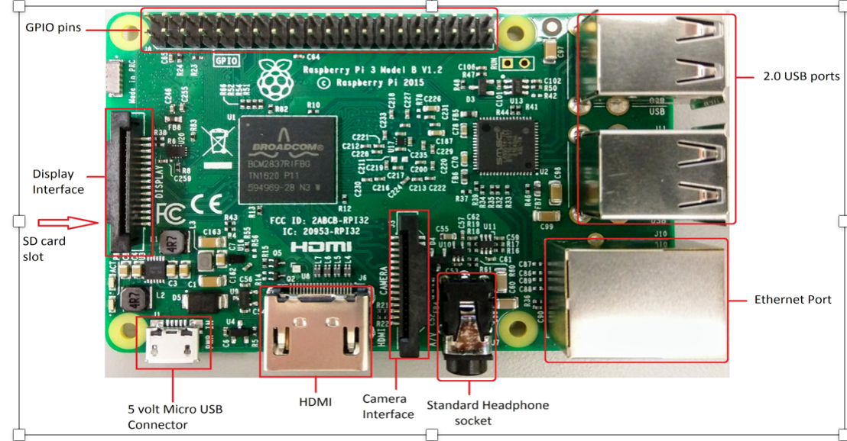

**The Raspberry Pi 3 is the third-generation Raspberry Pi. The following are its on board components**

● ARM CPU/GPU -- This is a Broadcom BCM 3287 System on a Chip (SoC) that's made up of an ARM central processing unit (CPU) and a Videocore 4 graphics processing unit (GPU). The CPU handles all the computations that make a computer work (taking input, doing calculations and producing output), and the GPU handles graphics output.

● GPIO -- These are exposed general-purpose input/output connection points that will allow the real hardware hobbyists the opportunity to tinker.

● RCA -- An RCA jack allows connection of analog TVs and other similar output devices.

● Audio out -- This is a standard 3.55-millimeter jack for connection of audio output devices such as headphones or speakers. There is no audio in.

● Camera Connector -- 15-pin MIPI Camera Serial Interface (CSI-2)

● Display Connector --Display Serial Interface (DSI) 15 way flat flex cable connector with two data lanes and a clock lane.

● USB -- This is a common connection port for peripheral devices of all types (including your mouse and keyboard). There are 4 USB2.0 Connectors.

● HDMI -- This connector allows you to hook up a high-definition television or other compatible device using an HDMI cable.

● Power -- This is a 5v Micro USB power connector into which you can plug your compatible power supply.

● SD card slot -- This is a full-sized SD card slot. An SD card with an operating system (OS) installed is required for booting the device. They are available for purchase from the manufacturers, but you can also download an OS and save it to the card yourself if you have a Linux machine and the wherewithal.

● Ethernet -- This connector allows for wired network access

**What are the GPIO Pins?**

Visible in the two below pictures, the GPIO pins are located on the Raspberry Pi in the top right corner. These pins are a physical interface between the Pi and the outside world. At the simplest level, you can think of them as switches that you can turn on or off (input) or that the Pi can turn on or off (output). Of the 40 pins, 26 are GPIO pins and the others are power or ground pins, plus two ID EEPROM pins.

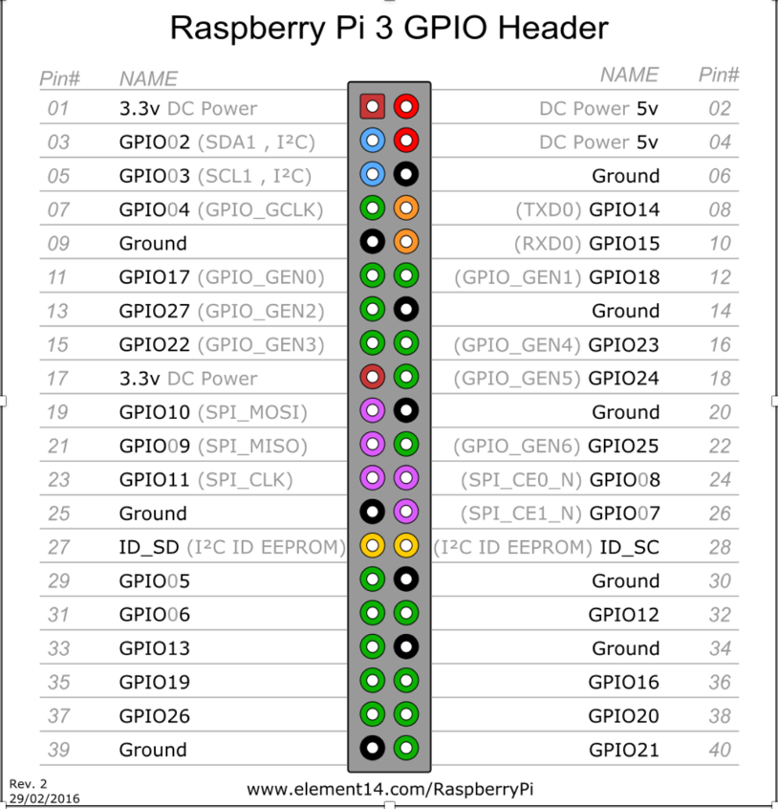

**What are they for? What can I do with them?**

You can program the pins to interact in amazing ways with the real world. Inputs don't have to come from a physical switch; it could be input from a sensor or a signal from another computer or device, for example. The output can also do anything, from turning on an LED to sending a signal or data to another device. If the Raspberry Pi is on a network, you can control devices that are attached to it from anywhere and those devices can send data back. Connectivity and control of physical devices over the internet is a powerful and exciting thing, and the Raspberry Pi is ideal for this.

**Pin Numbering System**

Raspberry Pi pins are numbered in two different ways - Physical numbering and Broadcom numbering (BCM). In the first case, the pins are numbered sequentially from one to 40. In the Figure 2, this is shown as Pin#. And the image represents what is seen when the Pi is held with the USB ports facing downwards. That is, Pin 2 is the pin in the corner. The Broadcom numbering system is the default option for the SoC (System-on-Chip). This is also known as GPIO numbering and is shown as Name in the Figure 2.

As you have probably guessed already, all the pins are not programmable. There are eight ground pins and two +5V pins and three +3.3V pins, which are not programmable. There are other dedicated pins too. Most of the pins have alternative functions, as shown in the figure. A majority of the pins are directly connected to the SoC; so while connecting circuits or components, one should be careful to avoid wrong wiring and short circuits. It is always good to have a descriptive pinout diagram printed out for quick reference.

# **Programming the Pins**

The Python package used for Raspberry Pi GPIO programming is RPi.GPIO. It is already installed in Raspbian, the default operating system for Pi. If you are using any other operating system, the package can be installed by using the following command:

# **The GPIO Programming Workflow**

Let us discuss the steps involved in writing a GPIO Python script, in general:

Let us discuss the steps involved in writing a GPIO Python script, in general:

1. Import the RPi.GPIO package.
2. Set the numbering style to be used. Use the method GPIO.setmode() for this. It takes either GPIO.BOARD or GPIO.BCM as the parameter. GPIO.BOARD stands for physical numbering and GPIO.BCM stands for Broadcom numbering.
3. Set up the necessary input and output pins.
4. Read inputs and give outputs.
5. Clean up GPIO and exit. You must clean up the pin set-ups before your program exits otherwise those pin settings will persist, and that might cause trouble when you use the same pins in another program. To clean up the entire set of pins, invoke GPIO.cleanup().

# **Set Up your Raspberry Pi**

To set up RPi, you will need:

● SD card of Minimum size 4Gb; Class 4 and above.

● HDMI for HD TVs and monitors with HDMI inpu

● Hdmi Cable.

● Keyboard and Mouse

● Power adapter

● A USB memory card reader

# **Preparing your SD card:**

The SD card contains the Raspberry Pi’s operating system (the OS is the software that makes it work, like Windows on a PC or OSX on a Mac). This is very different from most computers and it is what many people find the most daunting part of setting up their Raspberry Pi. The following instructions are for Windows users. Linux and Mac users can find instructions at [www.raspberrypi.org/downloads](http://www.raspberrypi.org/downloads)

**Steps to Follow**

**Step 1:**

Download the Raspberry Pi operating system The recommended OS is called Raspbian. Download it here:

[**https://www.raspberrypi.org/downloads/**](https://www.raspberrypi.org/downloads/)

**Step 2:**

a. Unzip the file that you just downloaded

b. Right click on the file and choose “Extract all”.

c. Follow the instructions—you will end up with a file ending in .img

**Step 3:**

a. 3.Download the Win32DiskImager software

b. Download win32diskimager-binary.zip http://sourceforge.net/projects/win32diskimager

c. Unzip it in the same way you did the Raspbian .zip file

d. You now have a new folder called win32diskimager-binary

**Step 4:**

a. Download the Win32DiskImager software

b. Download win32diskimager-binary.zip http://sourceforge.net/projects/win32diskimager

c. Unzip it in the same way you did the Raspbian .zip file

d. You now have a new folder called win32diskimager-binary

e. If the SD card (Device) you are using isn’t found automatically then click on the drop down box (highlighted in blue

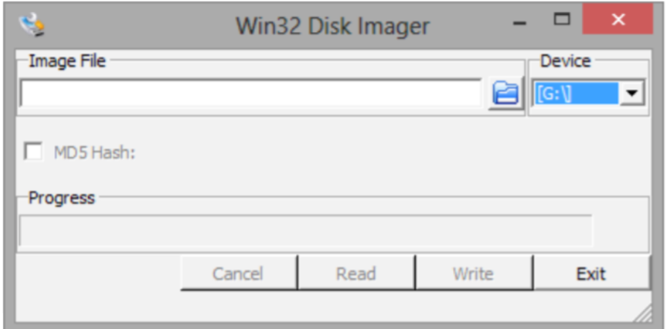

d. In the Image File box, choose the Raspbian .img file that you downloaded

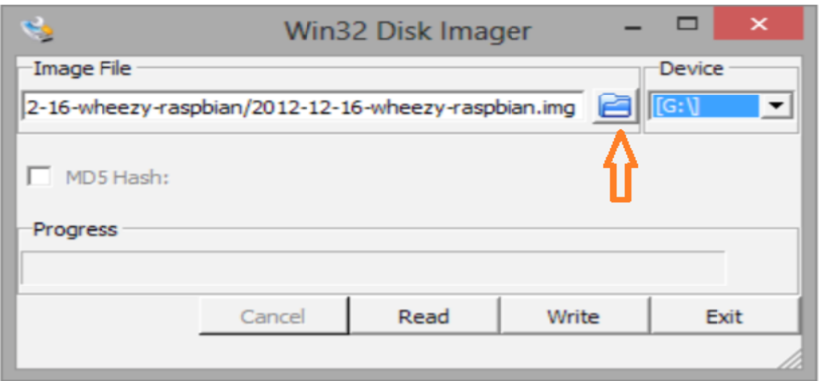

Click Write

f. After a few minutes you will have an SD card that you can use in the RPi.

**Step 5:**

Booting your Raspberry Pi for the first time

a. Connect the keyboard, mouse to the Pi

b. Next, connect the HDMI to the Pi and then to HDMI port on your display screen.

c. Now it is time to turn on our Raspberry Pi. When the memory card, HDMI lead, Ethernet cable, mouse and keyboard

are plugged in, plug in the power lead.

As soon as you do this. You screen should be black and filled with white text. This will be visible every time you turn on your raspberry pi.

**Step 6:**

Wait until you see raspberry pi Login Screen

● Username = pi [ENTER]

● Password = raspberry [ENTER]

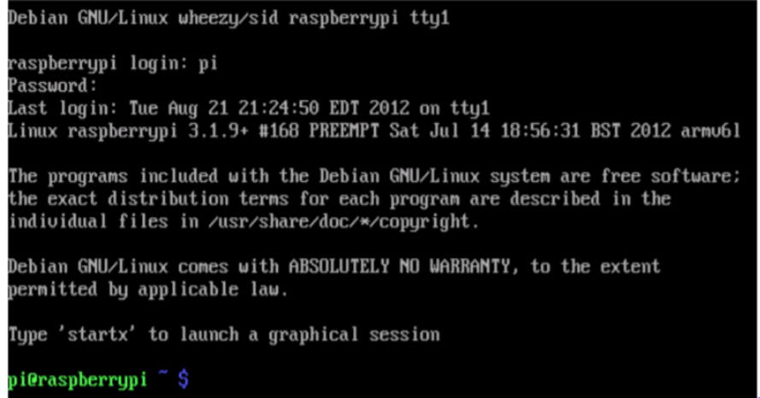

**Programming on the Raspberry Pi**

**Python:**

Python is a free to use programming language that runs on Windows, Linux/Unix, Mac OS X and has even been ported to Java and .NET virtual machines.

**Idle**

In order to create our python-run programmes we will first need to write them. This is where IDLE comes in.

IDLE is a special text editor software — like Microsoft Word — however it understands the language Python. This enables us to write in a language that our Raspberry Pi will be able to understand and interpret

**Key Applications of Raspberry Pi**

1. Low cost PC/tablet/laptop

2. Industrial/Home automation •

3. Print server

4. Wireless access point

5 Environmental sensing/monitoring (e.g. weather station)

6. IoT applications

7. Robotics

8. Server/cloud server

# **CONFIGURING GPIO PINS AS OUTPUTS - BLINKING LED [LAB 1B]**

**OBJECTIVE:** To learn basics about gpio pins, configuring them as outputs, learn to write basic python code and PWM for dimmable lights.

### **COMPONENTS:**

1) RPi 3

2) Breadboard

3) 100 Ω Resistor x 4

4) LED x 4

5) Connecting Wires

### Breadboard:

A breadboard is used for making an experimental model of an electric circuit. We are going to be using a half size solderless breadboard (plugboard). The reason for this is that you can simply push hardware in and out of the board without the need of soldering. This will ensure that if any mistakes are made you have not permanently damaged the hardware.

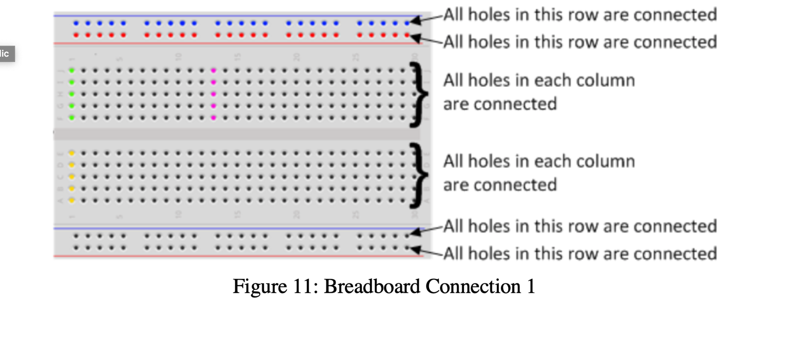

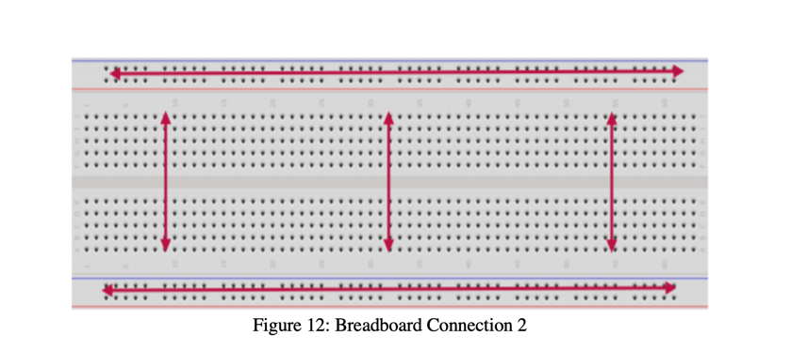

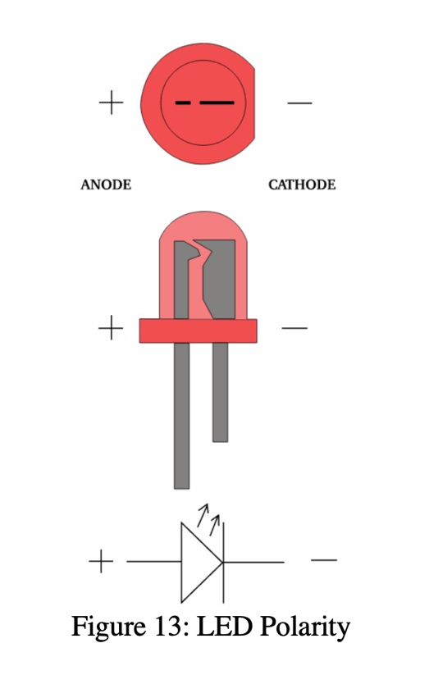

# CIRCUIT DIAGRAM:

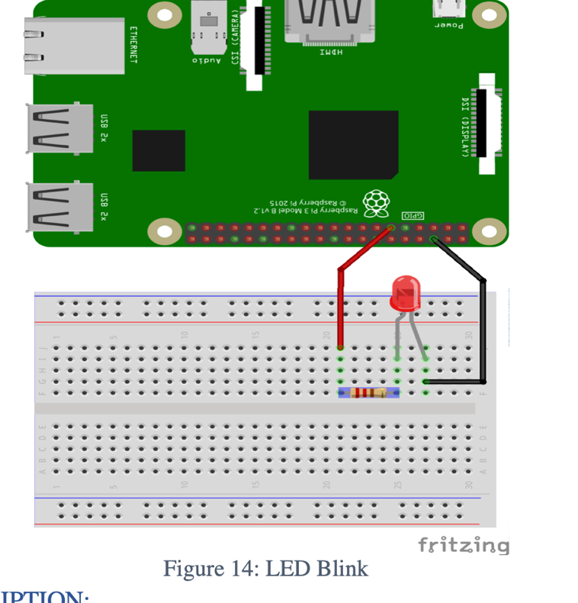

Connect the pin# 11 of RPi with 100 Ω resistor, and connect the other side of resistor with the positive (+) of LED. Connect the negative (-) of LED to the ground (GND) of RPi Pin# 6. Resistor is used to limit the current.

**CREATING THE PROGRAM:**

1. Go to TERMINAL
2. Create a folder for all our programs. Type the command:

$ mkdir workspace

1. Open this folder in your file system
2. Right click the mouse and choose new file and name it as lab1.py
3. Right click on the file and open with IDLE3. Make it default program.
4. Type the below code and save the file.
5. Go to terminal and navigate to workspace folder by typing the command:

$ cd workspace

Code

*# basic one time blink*

**import** **RPi.GPIO** **as** **GPIO**

**import** **time**

GPIO.setmode(GPIO.BOARD) *# to use Raspberry Pi board pin numbers*

GPIO.setup(11, GPIO.OUT) *# set up GPIO output channel*

GPIO.output(11, GPIO.LOW) *# set RPi board pin 11 low. Turn off LED.*

time.sleep(1)

GPIO.output(11, GPIO.HIGH) *# set RPi board pin 11 high. Turn on LED.*

**EXPLANATION**  
With reference to the above code:

●The first line tells the Python interpreter (the thing that runs the Python code) that it will be using a ‘library’ that will tell it how to work with the Raspberry Pi’s GPIO pins. A ‘library’ gives a programming language extra commands that can be used to do something different that it previously did not know how to do. This is like adding a new channel to your TV so you can watch something different.

●Imports the Time library so that we can pause the script later on.

●Each pin on the Pi has several different names, so you need to tell the program which naming convention is to be used. In the above case we are using physical pin numbering.

●Pin 11 is going to be used for outputting information, which means you are going to be able to turn the pin ‘on’ and ‘off’.

●GPIO.output(11, GPIO.HIGH) -- This turns the GPIO pin ‘on’. What this actually means is that the pin is made to provide power of 3.3volts. This is enough to turn the LED in our circuit on.

●time.sleep(2) -- Pauses the Python program for 2 second

# LED Fade Using Pulse Width Modulation **LAB 1C**

**OBJECTIVE:** PWM is a type of Digital Signal. A Digital Signal can have only two possible states, ON or OFF, 0 or 1, or in the case of this project, 0 or 3.3 volts. That’s why making the LED blink didn’t require PWM, because the LED was simply turning ON and OFF. In PWM signals, we can have both of these two states for a specified time period.

Suppose you want to control the brightness of an LED, the possible approach is to turn on an LED for a small period of time and then turn it off again for a small period of time. So, when this ON and OFF happens at very high speed, it gives the effect of dimmed LED.

### **COMPONENTS:**

1) RPi 3

2) Breadboard

3) 100 Ω Resistor x 4

4) LED x 4

5) Connecting Wires

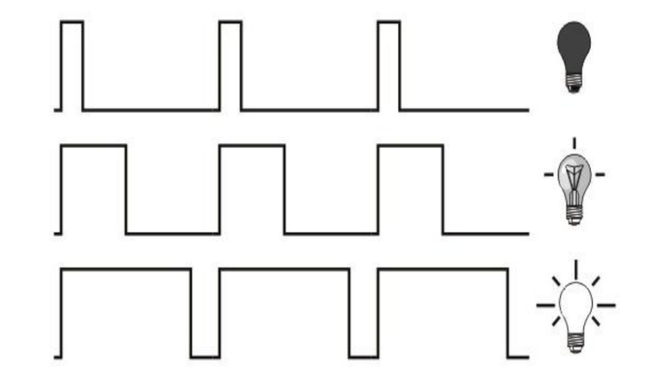

# CIRCUIT DIAGRAM:



Connect the pin# 11 of RPi with 100 Ω resistor, and connect the other side of resistor with the positive (+) of LED. Connect the negative (-) of LED to the ground (GND) of RPi Pin# 6. Resistor is used to limit the current.

Code

**import** **time**

GPIO.setwarnings(**False**)

GPIO.setmode (GPIO.BCM)

GPIO.setup(17,GPIO.OUT) *# initialize GPIO17 as an output.*

p = GPIO.PWM(17,100) *# 100Hz frequency*

p.start(0) *#start at 0% duty cycle*

**while** **True**:

**for** x **in** range (50):

p.ChangeDutyCycle(x)

time.sleep(0.1)

**for** x **in** range (50):

p.ChangeDutyCycle(50-x)

time.sleep(0.1)

# Flowing LED Lights

CIRCUIT DIAGRAM:

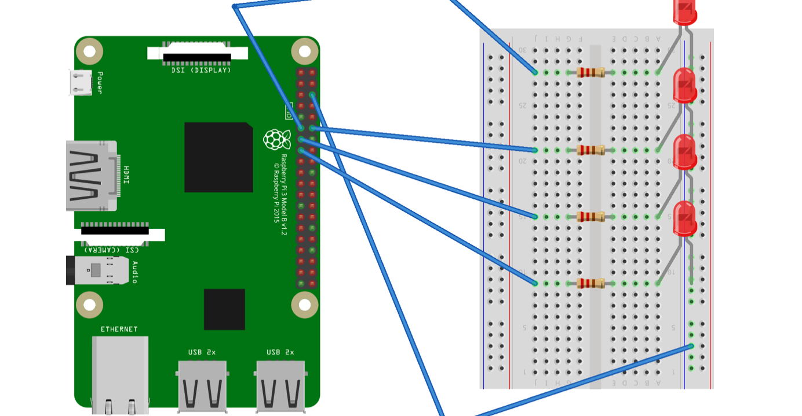

Code:

**import** **RPi.GPIO** **as** **GPIO**

**import** **time**

pins = [11, 12, 13, 15]

GPIO.setmode(GPIO.BOARD) *# to use Raspberry Pi board pin numbers*

**for** pin **in** pins:

GPIO.setup(pin, GPIO.OUT) *# Set all pins mode as output*

**def** setup():

**try**:

loop()

**except** **KeyboardInterrupt**: *# When 'Ctrl+C' is pressed, the child program destroy() will be executed.*

destroy()

**def** loop():

**while** **True**:

**for** pin **in** pins:

GPIO.output(pin, GPIO.LOW)

time.sleep(0.05)

GPIO.output(pin, GPIO.HIGH)

**for** pin **in** reversed(pins):

GPIO.output(pin, GPIO.LOW)

time.sleep(0.05)

GPIO.output(pin, GPIO.HIGH)

**def** destroy():

**for** pin **in** pins:

GPIO.output(pin, GPIO.HIGH)

GPIO.cleanup() *# Release resource*

setup()

**Introducing Tkinter with Raspberry pi [LAB 1D]**

**CIRCUIT DIAGRAM:**

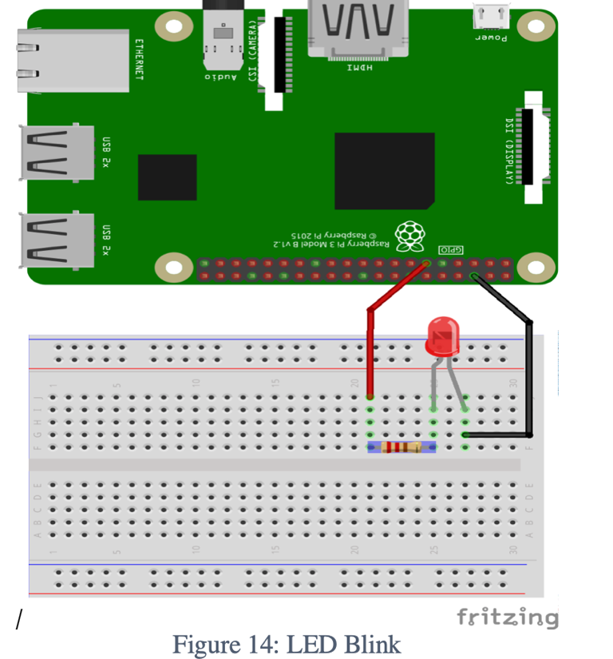

Code

*# import the important library*

**import** **tkinter** **as** **tk**

mainwindow=tk.Tk()

mainwindow.title('My First UI Test ')

mainwindow.geometry('640x340')

my_label=tk.Label(mainwindow,text=" On/Off ",

font=("Arial",22), bg= "Green",fg="white")

my_label.grid(row=0,column=0,sticky='NSEW',padx=10,pady=10)

button_on=tk.Button(mainwindow,text="On",bg="black",fg="white")

button_on.grid(row=1,column=0,sticky='NSEW',padx=10,pady=10)

button_off=tk.Button(mainwindow,text="OFF",bg="black",fg="white")

button_off.grid(row=1,column=1,columnspa=1,sticky='NSEW',padx=10,pady=10)

mainwindow.mainloop()

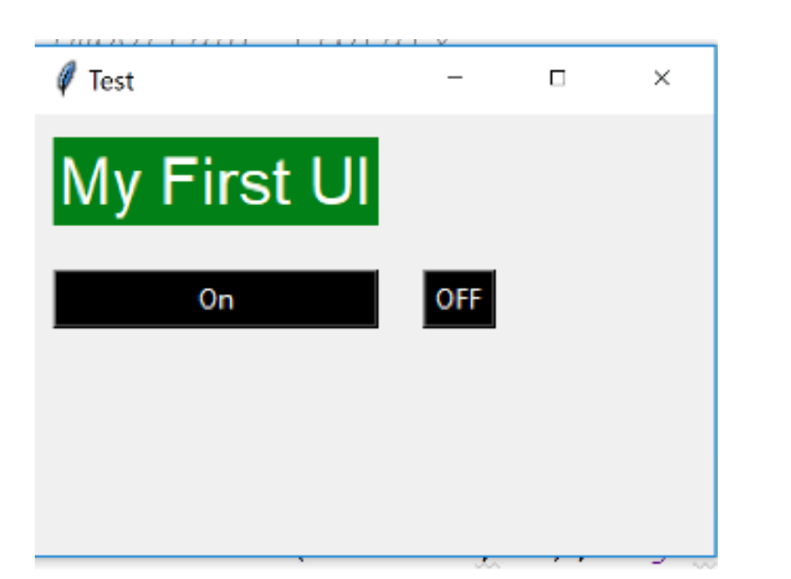

### **Step 2:** Adding Functionality to execute a function when Button is pressed using Lambda Function

*# import the important library*

**import** **tkinter** **as** **tk**

mainwindow=tk.Tk()

mainwindow.title('Test ')

mainwindow.geometry('640x340')

my_label=tk.Label(mainwindow,text="My First UI",

font=("Arial",22), bg= "Green",fg="white")

my_label.grid(row=0,column=0,sticky='NSEW',padx=10,pady=10)

button_on=tk.Button(mainwindow,text="On",bg="black",fg="white",

command=**lambda** :my_on())

button_on.grid(row=1,column=0,sticky='NSEW',padx=10,pady=10)

button_off=tk.Button(mainwindow,text="OFF",bg="black",fg="white",

command=**lambda**:my_off())

button_off.grid(row=1,column=1,columnspa=1,sticky='NSEW',padx=10,pady=10)

**def** my_on():

print('Led Turn On !!!!! ')

**def** my_off():

print('Led Turned Off !!!!!! ')

mainwindow.mainloop()

### **Step 3:** Add the Final code to Turn LED On/Off

*# import the important library*

**import** **tkinter** **as** **tk**

**import** **RPi.GPIO** **as** **GPIO**

**import** **time**

GPIO.setmode(GPIO.BOARD) *# to use Raspberry Pi board pin numbers*

GPIO.setup(11, GPIO.OUT) *# set up GPIO output channel*

mainwindow=tk.Tk()

mainwindow.title('Test ')

mainwindow.geometry('640x340')

my_label=tk.Label(mainwindow,text="My First UI",

font=("Arial",22), bg= "Green",fg="white")

my_label.grid(row=0,column=0,sticky='NSEW',padx=10,pady=10)

button_on=tk.Button(mainwindow,text="On",bg="black",fg="white",

command=**lambda** :my_on())

button_on.grid(row=1,column=0,sticky='NSEW',padx=10,pady=10)

button_off=tk.Button(mainwindow,text="OFF",bg="black",fg="white",

command=**lambda**:my_off())

button_off.grid(row=1,column=1,columnspa=1,sticky='NSEW',padx=10,pady=10)

**def** my_on():

print('Led Turn On !!!!! ')

GPIO.output(11, GPIO.LOW) *# set RPi board pin 11 low. Turn off LED.*

time.sleep(1)

print('Yes you did it !')

**def** my_off():

print('Led Turned Off !!!!!! ')

GPIO.output(11, GPIO.HIGH) *# set RPi board pin 11 high. Turn on LED.*

time.sleep(2)

print('Great Work ! ')

mainwindow.mainloop()

**Adding Database to our Project [LAB 1E]**

### **Objective**

We want to add time when we turned Lights on to our Database Let us learn how to do that for this, we would be using SQlite3 and make sure to download DB browser on Raspberry pi to open your database file.

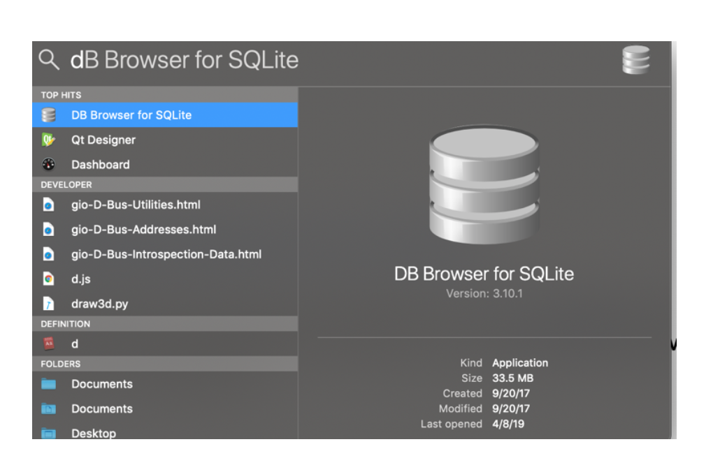

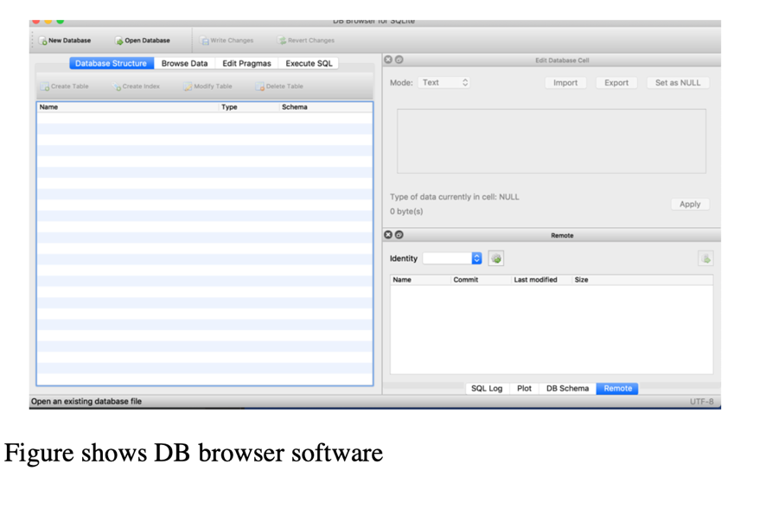

## CIRCUIT DIAGRAM:

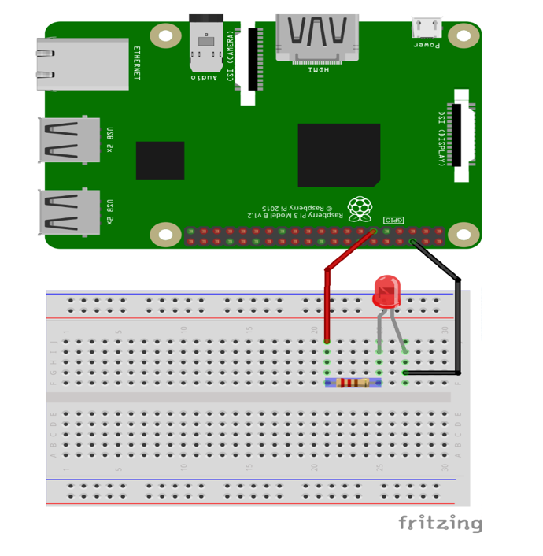

Code:

*# import the important library*

**import** **tkinter** **as** **tk**

**import** **RPi.GPIO** **as** **GPIO**

**import** **time**

**import** **datetime**

**import** **sqlite3**

GPIO.setmode(GPIO.BOARD) *# to use Raspberry Pi board pin numbers*

GPIO.setup(11, GPIO.OUT) *# set up GPIO output channel*

mainwindow=tk.Tk()

mainwindow.title('Test ')

mainwindow.geometry('640x340')

my_label=tk.Label(mainwindow,text="My First UI",

font=("Arial",22), bg= "Green",fg="white")

my_label.grid(row=0,column=0,sticky='NSEW',padx=10,pady=10)

button_on=tk.Button(mainwindow,text="On",bg="black",fg="white",

command=**lambda** :my_on())

button_on.grid(row=1,column=0,sticky='NSEW',padx=10,pady=10)

button_off=tk.Button(mainwindow,text="OFF",bg="black",fg="white",

command=**lambda**:my_off())

button_off.grid(row=1,column=1,columnspa=1,sticky='NSEW',padx=10,pady=10)

**def** my_on():

t=datetime.datetime.now()

my_t = "**{}**-**{}**-**{}**".format(t.hour,t.minute,t.second)

database_on(my_t)

print('Led Turn On !!!!! ')

GPIO.output(11, GPIO.LOW) *# set RPi board pin 11 low. Turn off LED.*

time.sleep(1)

print('Yes you did it !')

**def** my_off():

t=datetime.datetime.now()

my_off = "**{}**-**{}**-**{}**".format(t.hour,t.minute,t.second)

database_off(my_off)

print('Led Turned Off !!!!!! ')

GPIO.output(11, GPIO.HIGH) *# set RPi board pin 11 high. Turn on LED.*

time.sleep(2)

print('Great Work ! ')

**def** database_on(on_time):

conn = sqlite3.connect('led.db')

cursor = conn.cursor()

cursor.execute(""" CREATE TABLE IF NOT EXISTS

ledon

(id INTEGER PRIMARY KEY AUTOINCREMENT NOT NULL,

on_time TEXT)""")

cursor.execute("""

INSERT INTO ledon (on_time)

VALUES (?)""", (on_time))

conn.commit()

cursor.close()

conn.close()

**def** database_off(of_time):

conn = sqlite3.connect('led.db')

cursor = conn.cursor()

cursor.execute(""" CREATE TABLE IF NOT EXISTS

ledoff

(id INTEGER PRIMARY KEY AUTOINCREMENT NOT NULL,

off_time TEXT)""")

cursor.execute("""

INSERT INTO ledoff (off_time)

VALUES (?)""", (of_time))

conn.commit()

cursor.close()

conn.close()

mainwindow.mainloop()

Lab 1F

# **CONFIGURING GPIO PINS AS INPUTS - CONTROLLING LEDS FROM PUSH BUTTONS**

### **Objective**

Learn how to ‘read’ values from the Raspberry Pi GPIO pins, make dimmable LEDs with PWM and Push Buttons.

## **COMPONENTS:**

1) RPi 3

2) Breadboard

3) 330 Ω Resistor x 2

4) LED x 2

5) Push Buttons x 2

6) Connecting Wires

## Push Button

A pushbutton is a simple switch mechanism which permits user generated changes in the state of a circuit. Push Button usually comes with four legs. As you can see from the picture below, legs are always connected in groups of two. When the pushbutton is pressed all the 4 legs are connected

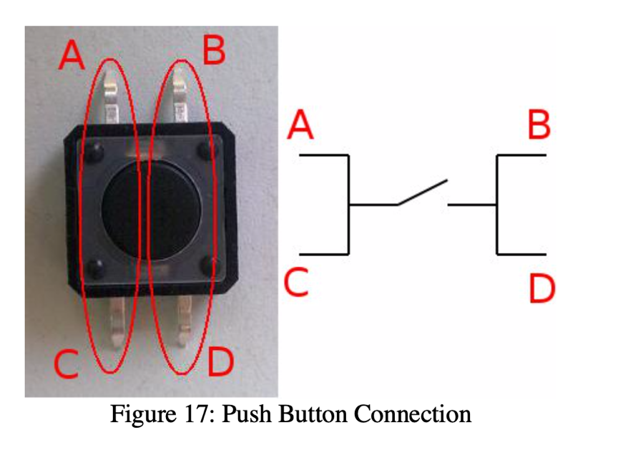

## CIRCUIT DIAGRAM:

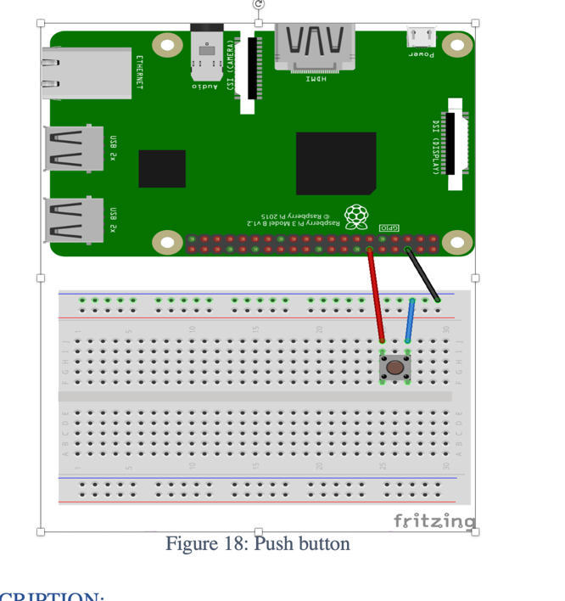

Code:

# Only button as input  
  
from time import sleep # Library will let us put in delays  
import RPi.GPIO as GPIO # Import the RPi Library for GPIO pin control  
  
button1_pin=12 # Button 1 is connected to physical pin 12  
  
GPIO.setmode(GPIO.BOARD) # Use Physical Pin Numbering Scheme  
GPIO.setup(button1_pin,GPIO.IN,pull_up_down=GPIO.PUD_UP)

# Make button1_pin an input, Activate Pull UP Resistor  
  
while(1): # Create an infinite Loop  
 input1=GPIO.input(button1_pin)  
  
 if input1==0: # Look for button 1 press  
 sleep(.1) # Delay  
 print ('Button 1 Pressed') # Notify User

Lab II

**Learn Interfacing Distance Sensor. [Lab 2]**

**OBJECTIVE:**

The idea of this park sensor is to show green when you have plenty of room to pull your car forward in parking lot, and then turn yellow as you approach the fully forward position, and then red when you should stop. Further, we improve it by adding a buzzer.

### **COMPONENTS:**

1) RPi 3

2) Breadboard

3) 330 Ω Resistor x 5

4) LED x 3 (Red, Yellow, Green)

5) HC-SR04 Ultrasonic Distance Sensor x 1

6) Active Buzzer x 1

7) Connecting Wires

**Explanation**

Ultrasonic Sensor: HC-SR04 is a commonly used module for non-contact distance measurement for distances from 2cm to 400cm. This sensor uses ultrasonic sound to measure distance just like bats and dolphins do. Ultrasonic sound has such a high pitch that humans cannot hear it. This particular sensor sends out an ultrasonic sound that has a frequency of about 40 kHz. The sensor has two main parts: a transducer that creates an ultrasonic sound and another that listens for its echo. The time difference between transmission and reception of ultrasonic signals is calculated. Using the speed of sound and ‘Speed = Distance/Time' equation, the distance between the source and target can be easily calculated.

Distance Calculation: Distance = Speed * Time/2 The "2" is in the formula because the sound has to travel back and forth. First the sound travels away from the sensor, and then it bounces off of a surface and returns back. we need only half of this. Therefore time is taken as time/2. Speed of sound at sea level = 340 m/s

Thus, Distance = 17150 * Time (unit cm) For accurate distance readings, the output can be calibrated using a ruler. In the below program a calibration of 0.5 cm is added.

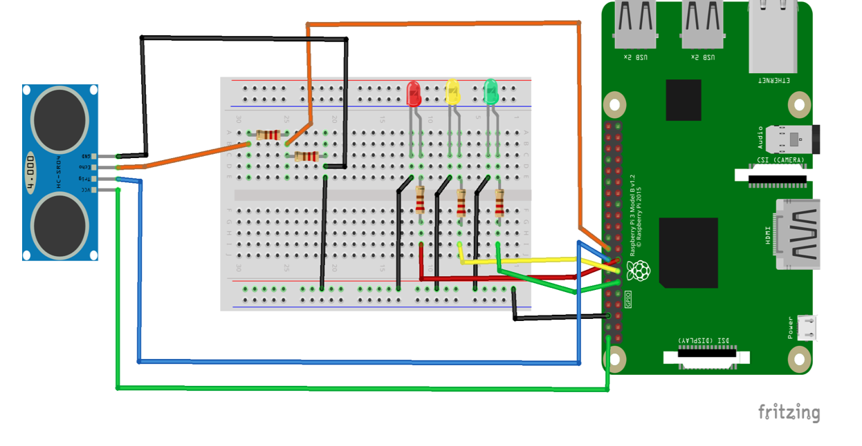

**CIRCUIT DESCRIPTION:**

1. BCM PIN CONFIGURATION IS USED.
2. VCC of the ultrasonic sensor is connected to 5v pin of RPi
3. Trigger to pin 23
4. Echo is connected to 330 ohm resistor and to pin 24.
5. 330 ohm resistors are for the leds and they are connecting to the positive leg of the leds and then GPIO.

### **CREATING THE PROGRAM:**

1. Go to TERMINAL
2. Navigate to workspace folder (created in lab 1) by typing the command: $ cd workspace
3. Open this folder in your file system
4. Right click the mouse and choose new file and name it as lab3.py
5. Right click on the file and open with IDLE3. Make it default program.
6. Type the below code and save the file.

**Code:**

**import RPi.GPIO as GPIO**

**import time**

**trigger_pin = 23**

**echo_pin = 24**

**red_pin = 22**

**yellow_pin = 27**

**green_pin = 17**

**def setup(): #method to setup pins and make led's low initially**

**GPIO.setmode(GPIO.BCM)**

**GPIO.setup(echo_pin, GPIO.IN)**

**GPIO.setup(trigger_pin, GPIO.OUT)**

**GPIO.setup(red_pin, GPIO.OUT)**

**GPIO.setup(yellow_pin, GPIO.OUT)**

**GPIO.setup(green_pin, GPIO.OUT)**

**GPIO.output(green_pin, GPIO.LOW)**

**GPIO.output(yellow_pin, GPIO.LOW)**

**GPIO.output(red_pin, GPIO.LOW)**

**try:**

**print('calling loop')**

**calculate_distance() #calling distance calculation method**

**except KeyboardInterrupt: #cleaning pins on program exit**

**print('cleaning up gpio pins')**

**GPIO.cleanup()**

**def red():**

**GPIO.output(red_pin, GPIO.HIGH)**

**GPIO.output(green_pin, GPIO.LOW)**

**GPIO.output(yellow_pin, GPIO.LOW)**

**def yellow():**

**GPIO.output(yellow_pin, GPIO.HIGH)**

**GPIO.output(red_pin, GPIO.LOW)**

**GPIO.output(green_pin, GPIO.LOW)**

**def green():**

**GPIO.output(green_pin, GPIO.HIGH)**

**GPIO.output(yellow_pin, GPIO.LOW)**

**GPIO.output(red_pin, GPIO.LOW)**

**def calculate_distance():**

**while True:**

**GPIO.output(trigger_pin, False) #set trigger_pin as LOW**

**print ("Giving delay between distance measuring cycle")**

**time.sleep(0.5)**

**GPIO.output(trigger_pin, True) #set trigger_pin as HIGH**

**time.sleep(0.00001)**

**GPIO.output(trigger_pin, False)**

**while GPIO.input(echo_pin)==0: #check if echo_pin is LOW**

**pulse_start = time.time() #saves the last known time of LOW pulse**

**while GPIO.input(echo_pin)==1: #Check if echo_pin is HIGH**

**pulse_end = time.time() #saves the last known time of HIGH pulse**

**pulse_duration = pulse_end - pulse_start #get pulse duration to a variable**

**distance = pulse_duration * 17150 #multiply pulse duration by 17150 to get distance**

**distance = round(distance, 2) #round to two decimal points**

**print ("Distance:",distance - 0.5,"cm") #print distance with 0.5 cm calibration**

**if distance <= 5: #call red method if distance is less than or equal to 5cm**

**red()**

**elif 6 <= distance < 20: #call yellow method if distance is greater than 6cm and less than 20cm**

**yellow()**

**elif 21 <= distance < 150: #call green method if distance is greater than 21cm and less than 150cm**

**green()**

**else:**

**print("Out of Range")**

**setup()**

## **EXPLANATION:**

With reference to the above code:

If the distance is greater than or equal to 5 cm, we show a red light. If it's between 6 and 20 cm, we'll turn yellow, and then we'll turn green for greater than or equal to 21 cm and less than 150cm.

# Distance Sensor Data Logging on a Database using SQLITE3 [Lab 2A]

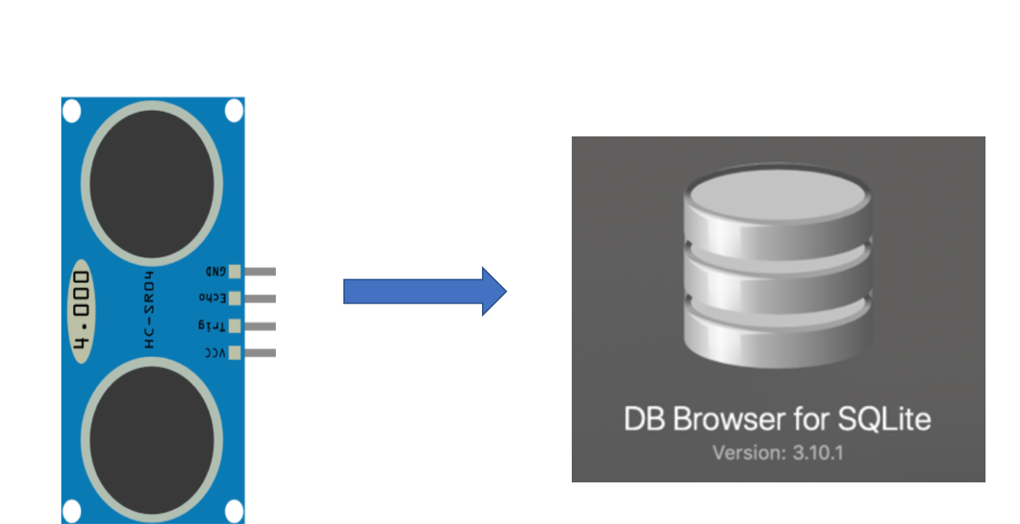

So far, we learned how to interface Distance Sensor with Raspberry pi let us include a database. In this experiment we try to log the sensor value to the database with time when it was recorded. Please make sure to follow or connect the pins correctly in this example I am using trigger pin GPIO 17 and echo as GPIO as 27

Code:

import RPi.GPIO as GPIO

import time

import datetime

#GPIO Mode (BOARD / BCM)

GPIO.setmode(GPIO.BCM)

#set GPIO Pins

GPIO_TRIGGER = 23

GPIO_ECHO = 24

#set GPIO direction (IN / OUT)

GPIO.setup(GPIO_TRIGGER, GPIO.OUT)

GPIO.setup(GPIO_ECHO, GPIO.IN)

def get_time():

t = datetime.datetime.now()

my_time ='{}:{}:{}'.format(t.hour,t.minute,t.second)

return my_time

def distance():

# set Trigger to HIGH

GPIO.output(GPIO_TRIGGER, True)

# set Trigger after 0.01ms to LOW

time.sleep(0.00001)

GPIO.output(GPIO_TRIGGER, False)

StartTime = time.time()

StopTime = time.time()

# save StartTime

while GPIO.input(GPIO_ECHO) == 0:

StartTime = time.time()

# save time of arrival

while GPIO.input(GPIO_ECHO) == 1:

StopTime = time.time()

# time difference between start and arrival

TimeElapsed = StopTime - StartTime

# multiply with the sonic speed (34300 cm/s)

# and divide by 2, because there and back

distance = (TimeElapsed * 34300) / 2

my_time = get_time()

my_database(distance, my_time)

return distance

def my_database(distance,my_time):

"""

:return: Nothing

"""

# define the connection

conn = sqlite3.connect("distance.db")

#define the cursor

cursor = conn.cursor()

# create Tables

cursor.execute("""

CREATE TABLE IF NOT EXISTS my_table (id INTEGER PRIMARY KEY AUTOINCREMENT NOT NULL,

distance TEXT,

my_time TEXT)""")

# Add data to database

cursor.execute("""

INSERT INTO my_table (distance,my_time) VALUES (?, ?)""",(distance, my_time))

# perform 3C

#COMMIT, CLOSE CLOSE

conn.commit()

cursor.close()

conn.close()

if __name__ == '__main__':

try:

while True:

dist = distance()

print ("Measured Distance = %.1f cm" % dist)

time.sleep(1)

# Reset by pressing CTRL + C

except KeyboardInterrupt:

print("Measurement stopped by User")

GPIO.cleanup()

# Interfacing DHT-11/ DHT-22 Sensor with Raspberry Pi [Lab 2B]

**Objective:** To learn how to interface DHT-11/DHT-22 Sensor with Raspberry pi. Later we shall add SQLITE Database and try to upload the code on Cloud.

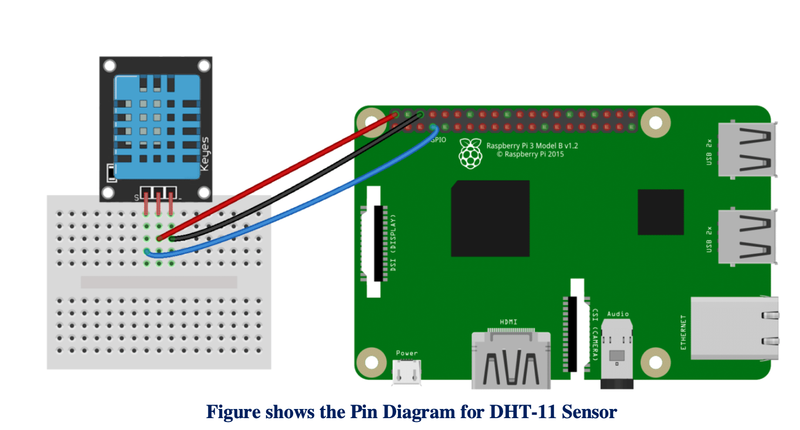

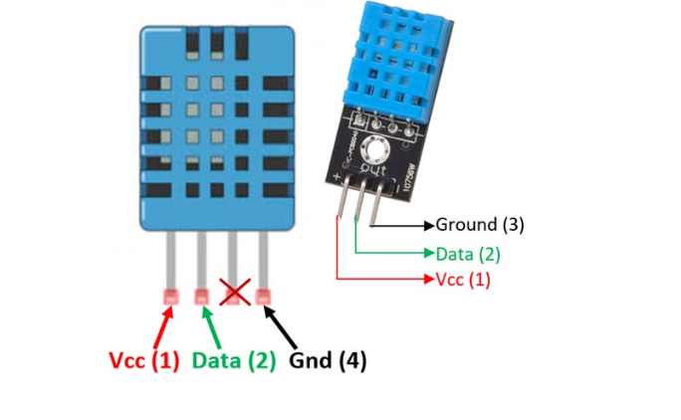

# Please follow complete Steps on how to install the Library on following link

# <https://github.com/adafruit/Adafruit_Python_DHT>

**Installation Steps: -**

Python library to read the DHT series of humidity and temperature sensors on a Raspberry Pi or Beaglebone Black. Designed specifically to work with the Adafruit DHT series sensors ----> <https://www.adafruit.com/products/385> Currently the library is tested with Python 2.6, 2.7, 3.3 and 3.4. It should work with Python greater than 3.4, too Dependencies

For all platforms (Raspberry Pi and Beaglebone Black) make sure your system is able to compile and download Python extensions with pip:

On Raspbian or Beaglebone Black's Debian/Ubuntu image you can ensure your system is ready by running one or two of the following sets of commands

Python 2: sudo apt-get update sudo apt-get install python-pip sudo python -m pip install --upgrade pip setuptools wheel

Python 3: sudo apt-get update sudo apt-get install python3-pip sudo python3 -m pip install --upgrade pip setuptools wheel

Install with pip Use pip to install from PyPI.

Python 2: sudo pip install Adafruit_DHT

Python 3: sudo pip3 install Adafruit_DHT

Compile and install from the repository First download the library source code from the GitHub releases page, unzipping the archive, and execute: Python 2: cd Adafruit_Python_DHT sudo python setup.py install

Python 3: cd Adafruit_Python_DHT sudo python3 setup.py install

You may also git clone the repository if you want to test an unreleased version: git clone <https://github.com/adafruit/Adafruit_Python_DHT.git>

# Task 1: Read the sensor

# Code:

# import Adafruit_DHT

# # Example using a Raspberry Pi with DHT sensor

# # connected to GPIO23.

# pin = 4

# sensor = Adafruit_DHT.DHT22

# humidity, temperature = Adafruit_DHT.read_retry(sensor, pin)

# if humidity is not None and temperature is not None:

# print('Temp={0:0.1f}*C Humidity={1:0.1f}%'.format(temperature, humidity))

# else:

# print('Failed to get reading. Try again!')

Run the above Code and if you get the Temperature and humidity congregations and let’s move ahead. Let’s try to read the sensor value continuously we just need to add a while loop

# Task 2: Read the sensor value continuously.[¶](http://localhost:8888/notebooks/Desktop/IoT%20Fall%202019/LAB%202/Ipython%20Notebook/Lab%202B.ipynb#Task-2:-Read-the-sensor-value-continuously.)

# Code:

# import Adafruit_DHT

# # Example using a Raspberry Pi with DHT sensor

# # connected to GPIO23.

# pin = 4

# sensor = Adafruit_DHT.DHT22

# while 1:

# humidity, temperature = Adafruit_DHT.read_retry(sensor, pin)

# if humidity is not None and temperature is not None:

# print('Temp={0:0.1f}*C Humidity={1:0.1f}%'.format(temperature, humidity))

# if humidity >34:

# print("Alert ")

# else:

# print('Failed to get reading. Try again!')

# Task 3: Try to create a UI where you can display Temperature and Humidity continuously

# import tkinter as tk

# import numpy as np

# import random

# import time

# import datetime

# import threading

# import Adafruit_DHT

# pin = 4

# sensor = Adafruit_DHT.DHT22

# def tick():

# time2=time.strftime('%H:%M:%S')

# clock.config(text=time2)

# clock.after(200,tick)

# def get_data():

# threading.Timer(5, get_data).start()

# humidity, temperature = Adafruit_DHT.read_retry(sensor, pin)

# if humidity is not None and temperature is not None:

# print('Temp={0:0.1f}*C Humidity={1:0.1f}%'.format(temperature, humidity))

# l_display.config(text = temperature)

# else:

# print('Failed to get reading. Try again!')

# return temperature

# mainwindow = tk.Tk()

# mainwindow.geometry('640x340')

# mainwindow.title("Sensor Data Live Feed ")

# clock=tk.Label(mainwindow,font=("Arial",30), bg='green',fg="white")

# clock.grid(row=0, column=0, padx=10, pady=10, sticky="nsew")

# l_m=tk.Label(mainwindow,text="Sensor Data ",font=("Arial",30),fg="Black")

# l_m.grid(row=0,column=1, padx=10, pady=10, sticky="nsew")

# l_t=tk.Label(mainwindow, text="Temperature C",font=("Arial",25))

# l_t.grid(row=1,column=0, padx=10, pady=10, sticky="nsew")

# l_display=tk.Label(mainwindow,font=("Arial",25),fg="red")

# l_display.grid(row=1,column=1, padx=10, pady=10, sticky="nsew")

# tick()

# get_data()

# mainwindow.mainloop()

# Task 4: Try to Log the value on Database[¶](http://localhost:8888/notebooks/Desktop/IoT%20Fall%202019/LAB%202/Ipython%20Notebook/Lab%202B.ipynb#Task-4:-Try-to-Log-the-value-on-Database)

# import Adafruit_DHT

# import sqlite3

# import threading

# import datetime

# def get_time():

# my=datetime.datetime.now()

# data_time = '{}:{}:{}'.format(my.hour,my.minute,my.second)

# data_date='{}/{}/{}'.format(my.day,my.month,my.year)

# return data_date,data_time

# def my_database(x, y,my_time, my_date):

# """

# :return: Nothing

# """

# # define the connection

# conn = sqlite3.connect("xyz.db")

# #define the cursor

# cursor = conn.cursor()

# # create Tables

# cursor.execute("""

# CREATE TABLE IF NOT EXISTS my_table (id INTEGER PRIMARY KEY AUTOINCREMENT NOT NULL,

# temperature TEXT,

# humidity TEXT,

# m_date TEXT,

# m_time TEXT)""")

# # Add data to database

# cursor.execute("""

# INSERT INTO my_table (temperature,humidity,m_date,m_time) VALUES (?, ?, ?, ?)""",(x, y,my_time, my_date))

# # perform 3C

# #COMMIT, CLOSE CLOSE

# conn.commit()

# cursor.close()

# conn.close()

# def main():

# threading.Timer(10, main).start()

# pin = 4

# sensor = Adafruit_DHT.DHT22

# humidity, temperature = Adafruit_DHT.read_retry(sensor, pin)

# if humidity is not None and temperature is not None:

# print('Temp={0:0.1f}*C Humidity={1:0.1f}%'.format(temperature, humidity))

# data_date,data_time = get_time()

# print('Date',data_date)

# my_database(temperature, humidity,data_time,data_date)

# print("data was written on database T{} H{}".format(temperature,humidity))

# else:

# print('Failed to get reading. Try again!')

# if __name__ == '__main__':

# while 1:

# main()

# Objective Learn to Interface Camera Module

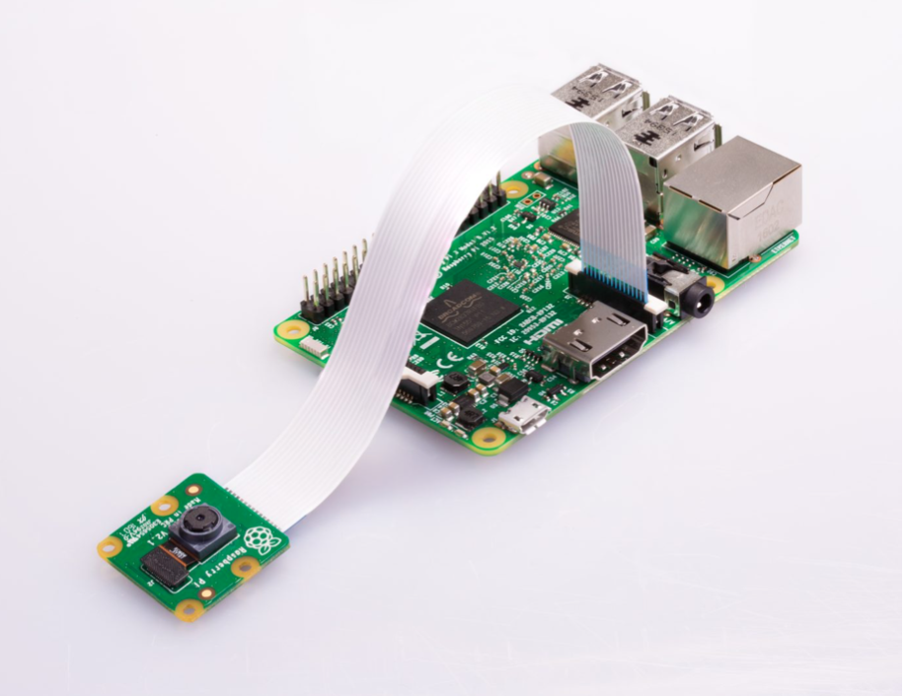

# Code:

# import time

# from picamera import PiCamera

# camera=PiCamera()

# #camera.start_preview()

# time.sleep(2)

# camera.capture("yo.jpg")

# Modify the Code to whenever you press button it takes Photo

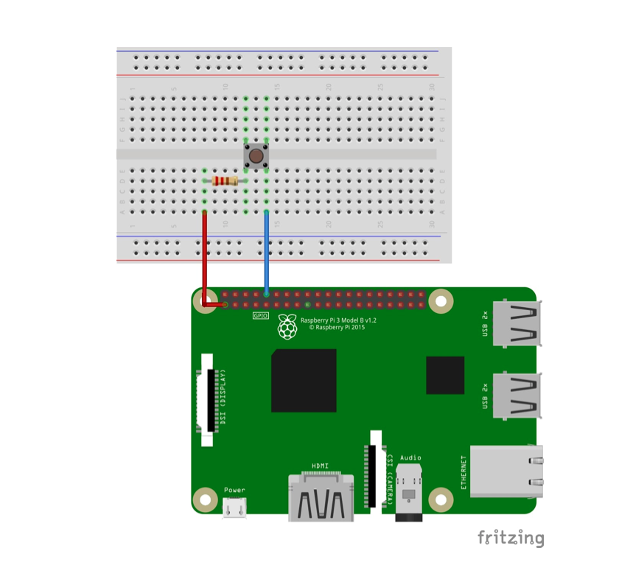

# Code

# import time

# from picamera import PiCamera

# from time import sleep # Library will let us put in delays

# import RPi.GPIO as GPIO # Import the RPi Library for GPIO pin control

# button1_pin=10 # Button 1 is connected to physical pin 12

# GPIO.setmode(GPIO.BOARD) # Use Physical Pin Numbering Scheme

# GPIO.setup(button1_pin,GPIO.IN,pull_up_down=GPIO.PUD_UP)

# # Make button1_pin an input, Activate Pull UP Resistor

# while(1): # Create an infinite Loop

# input1=GPIO.input(button1_pin)

# if input1==0:

# sleep(.1)

# print ('Button 1 Pressed')

# # Look for button 1 press # Delay

# # Notify User

# camera=PiCamera()

# #camera.start_preview()

# time.sleep(2)

# camera.capture("soumil.jpg")

Lab III

**Send Data from one Raspberry pi to another Raspberry Pi [Lab 3]**

**Objective:**

In this Experiment we shall learn to create our own server and client with raspberyy pi uisng python Socket Programming.

Our Target is to create a server. the server would be Running 24x7 on Raspberry pi and server is always listening for request from client When a client request server it shall send the Temperature and Humidity over Network using Socket Programming

**Tutorial:**

https://www.youtube.com/watch?v=QihjI84Z2tQ



### Connection Diagram

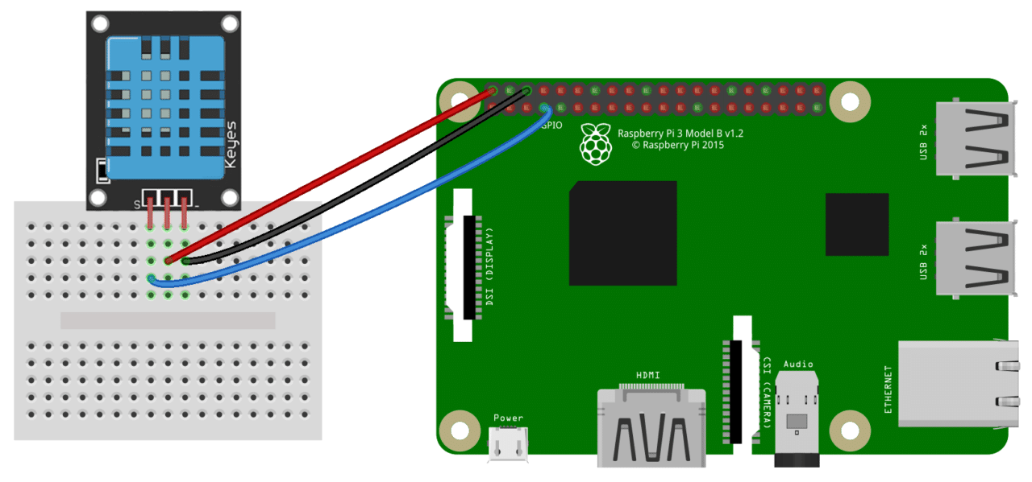

### DHT Pinout

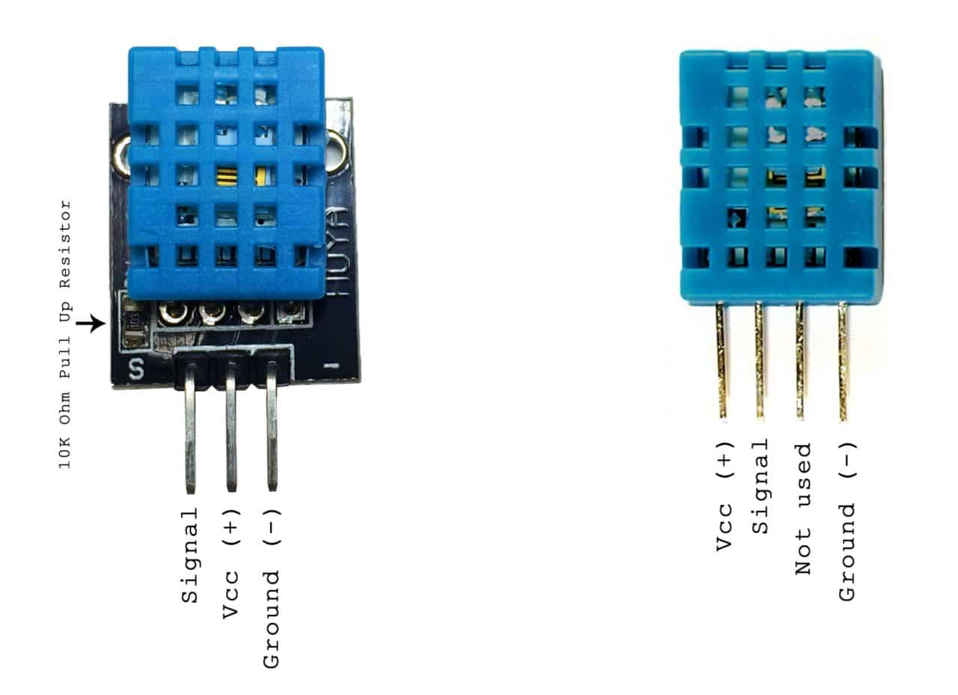

# **Step 1: Create Server:**

Define the Library

import socket

import numpy as np

import encodings

Define the HOST and PORT

HOST = '127.0.0.1' # Standard loopback interface address (localhost)

PORT = 65432 # Port to listen on (non-privileged ports are > 1023)

For the Experiment we shall send Dummy Data and then once we know the concept we can send actual Sensor value over the socket programming.

### Define the function which will send dummy data when client sends request

### def random_data():

### x1 = np.random.randint(0, 55, None) # Dummy temperature

### y1 = np.random.randint(0, 45, None) # Dummy humidigy

### my_sensor = "{},{}".format(x1,y1)

### return my_sensor

### Define the actual server when client sends string Data it shall send Data

def my_server():

with socket.socket(socket.AF_INET, socket.SOCK_STREAM) as s:

print("Server Started waiting for client to connect ")

s.bind((HOST, PORT))

s.listen(5)

conn, addr = s.accept()

with conn:

print('Connected by', addr)

while True:

data = conn.recv(1024).decode('utf-8')

if str(data) == "Data":

print("Ok Sending data ")

my_data = random_data()

x_encoded_data = my_data.encode('utf-8')

conn.sendall(x_encoded_data)

elif str(data) == "Quit":

print("shutting down server ")

break

if not data:

break

else:

pass

if __name__ == '__main__':

while 1:

my_server()

### Explanation[¶](http://localhost:8888/notebooks/Desktop/Important%20Documents%20/IoT%20final/Combined/Lab%203/Lab%203.ipynb#Explanation)

when client sends Data as a string server will send sensor data over the network

# **Entire Code for Server**

import socket

import numpy as np

import encodings

HOST = '127.0.0.1' # Standard loopback interface address (localhost)

PORT = 65432 # Port to listen on (non-privileged ports are > 1023)

def random_data():

x1 = np.random.randint(0, 55, None) # Dummy temperature

y1 = np.random.randint(0, 45, None) # Dummy humidigy

my_sensor = "{},{}".format(x1,y1)

return my_sensor # return data seperated by comma

def my_server():

with socket.socket(socket.AF_INET, socket.SOCK_STREAM) as s:

print("Server Started waiting for client to connect ")

s.bind((HOST, PORT))

s.listen(5)

conn, addr = s.accept()

with conn:

print('Connected by', addr)

while True:

data = conn.recv(1024).decode('utf-8')

if str(data) == "Data":

print("Ok Sending data ")

my_data = random_data()

x_encoded_data = my_data.encode('utf-8')

conn.sendall(x_encoded_data)

elif str(data) == "Quit":

print("shutting down server ")

break

if not data:

break

else:

pass

if __name__ == '__main__':

while 1:

my_server()

# **Step 2: Write the Code for Client**

Define the Library

import socket

import numpy as np

import encodings

Define the HOST and PORT

HOST = '192.168.0.111' # The server's hostname or IP address

PORT = 65432 # The port used by the server

### we need to process the Data that server sends us lets us define a function for that[¶](http://localhost:8888/notebooks/Desktop/Important%20Documents%20/IoT%20final/Combined/Lab%203/Lab%203.ipynb#we-need-to-process-the-Data-that-server-sends-us-lets-us-define-a-function-for-that)

def process_data_from_server(x):

x1, y1 = x.split(",")

return x1,y1

### Write the Client Code:

### def my_client():

### threading.Timer(11, my_client).start()

### with socket.socket(socket.AF_INET, socket.SOCK_STREAM) as s:

### s.connect((HOST, PORT))

### my = input("Enter command ")

### #my = "Data"

### my_inp = my.encode('utf-8')

### s.sendall(my_inp)

### data = s.recv(1024).decode('utf-8')

### x_temperature,y_humidity = process_data_from_server(data)

### print("Temperature {}".format(x_temperature))

### print("Humidity {}".format(y_humidity))

### s.close()

### time.sleep(5)

if __name__ == "__main__":

while 1:

my_client()

**Entire Client Code**

import socket

import threading

import time

HOST = '192.168.0.111' # The server's hostname or IP address

PORT = 65432 # The port used by the server

def process_data_from_server(x):

x1, y1 = x.split(",")

return x1,y1

def my_client():

threading.Timer(11, my_client).start()

with socket.socket(socket.AF_INET, socket.SOCK_STREAM) as s:

s.connect((HOST, PORT))

my = input("Enter command ")

#my = "Data"

my_inp = my.encode('utf-8')

s.sendall(my_inp)

data = s.recv(1024).decode('utf-8')

x_temperature,y_humidity = process_data_from_server(data)

print("Temperature {}".format(x_temperature))

print("Humidity {}".format(y_humidity))

s.close()

time.sleep(5)

if __name__ == "__main__":

while 1:

my_client()

**part II**

# **Great Job try the Code and lets send Actual Sensor Data over Network**[**¶**](http://localhost:8888/notebooks/Desktop/Important%20Documents%20/IoT%20final/Combined/Lab%203/Lab%203.ipynb#Great-Job-try-the-Code-and-lets-send-Actual-Sensor-Data-over-Network)

# **Server Code which will run on Raspberry pi**

import socket

import numpy as np

import encodings

import Adafruit_DHT

HOST = '192.168.1.4' # Standard loopback interface address (localhost)

PORT = 65432 # Port to listen on (non-privileged ports are > 1023)

def random_data():

pin = 4

sensor = Adafruit_DHT.DHT22

humidity, temperature = Adafruit_DHT.read_retry(sensor, pin)

if humidity is not None and temperature is not None:

print('Temp={0:0.1f}*C Humidity={1:0.1f}%'.format(temperature, humidity))

print("data was written on database T{} H{}".format(temperature,humidity))

data = '{},{}'.format(temperature,humidity)

return data

def my_server():

with socket.socket(socket.AF_INET, socket.SOCK_STREAM) as s:

print("Server Started waiting for client to connect ")

s.bind((HOST, PORT))

s.listen(5)

conn, addr = s.accept()

with conn:

print('Connected by', addr)

while True:

data = conn.recv(1024).decode('utf-8')

if str(data) == "Data":

print("Ok Sending data ")

my_data = random_data()

x_encoded_data = my_data.encode('utf-8')

conn.sendall(x_encoded_data)

elif str(data) == "Quit":

print("shutting down server ")

break

if not data:

break

else:

pass

if __name__ == '__main__':

while 1:

my_server()

# Client Code will be same as Above.

Lab IV

Lab 4

**Getting started with Open Source Cloud Server Upload any Sensor Data to cloud Server ThingSpeak Complete Tutorial Read, Write with Example**

## **ThingSpeak:**

There are two ways one is hard way without library and another with library

### **Video Tutorial can be Found Below Link:**

1. Hard way



[**https://www.youtube.com/watch?v=jYeUS7JxmA8**](https://www.youtube.com/watch?v=jYeUS7JxmA8)

1. **Easy way:**



<https://www.youtube.com/watch?v=HM7_Urqoric>

# Step 1: Go thingspeak website and Create your Account



After creating your Account we ned to copy Read and Write API Keys shown in image below

# Step 2: Copy Credentials all all API keys

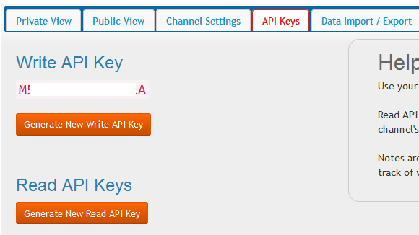

# We are Going to Learn Both ways

1. Upload the Data with 3 lines of code using Library that i have developed
2. Upload using URLlib and request Module

# Method 1: Harder way

Write Data

import urllib.request

import requests

import threading

import json

import random

def thingspeak_post():

threading.Timer(15,thingspeak_post).start()

val=random.randint(1,30)

URl='https://api.thingspeak.com/update?api_key='

KEY=' -------WRITE KEY----------'

HEADER='&field1={}&field2={}'.format(val,val)

NEW_URL = URl+KEY+HEADER

print(NEW_URL)

data=urllib.request.urlopen(NEW_URL)

print(data)

if __name__ == '__main__':

thingspeak_post()

# Method 2 Easy way with Three Line of Code

## **important Note:**

Assume your name of your python file is main and the code that i am about to show you is the library developed to do jon in 3 lines of code. Paster the Entire 500 Line of code in your File called main and all way down start writing your code

or

copy the library ie python file in your working Directory and you can simple say from nameofpythonfile import *

# Assume your Work Directory is

Foldername ---- IoTclass

> main.py

> masterclass.py

in your main Python File you will say from masterclass import *

if that dosent work for some reason you can also copy entire 500 Line of library code in main.py and all the way down start writing your code

## Code

from masterclass import *

temperature = 22

humidity = 11

w_key = 'AZRMN9ZP5FKLXYLR'

r_key = '17FSCQ4FTX6V4VWM'

channel_id = 83234

ob = Thingspeak(write_api_key=w_key, read_api_key=r_key, channel_id=channel_id)

ob.post_cloud(value1=temperature,value2=humidity)

# Sample Code using Master class.

### Use this Template for Coding !

try:

import numpy as np

from masterclass import *

except:

print("Library not Found ! ")

x = []

y1 = []

y2 = []

def sensor_random_value():

"""

Write you Raspberry pi Sensor Code Inside this

:return: Comma Seperated Values

"""

x = np.random.randint(0, 20, None) # create random value which resenble to sensor data Live

y = np.random.randint(0, 20, None) # create a another random variable to store Data Sensor 2

my_sensor = "{},{}".format(x, y) # create a Fake Data which represent the hardware data

return my_sensor

def mymain():

x,y = sensor_random_value().split(',')

w_key = 'AZRMN9ZP5FKLXYLR'

r_key = '17FSCQ4FTX6V4VWM'

channel_id = 83234

ob = Thingspeak(write_api_key=w_key, read_api_key=r_key, channel_id=channel_id)

ob.post_cloud(value1=x,value2=y)

if __name__ == "__main__":

mymain()

**Task 1: Upload DHT-11 Sensor Data to Cloud Server !**

try:

import Adafruit_DHT

from masterclass import *

except:

print("Library not Found !")

def sensor_value():

# Example using a Raspberry Pi with DHT sensor

# connected to GPIO23.

pin = 4

sensor = Adafruit_DHT.DHT22

humidity, temperature = Adafruit_DHT.read_retry(sensor, pin)

if humidity is not None and temperature is not None:

print('Temp={0:0.1f}*C Humidity={1:0.1f}%'.format(temperature, humidity))

data = '{},{}'.format(temperature,humidity)

return data

else:

print('Failed to get reading. Try again!')

def my_main():

x,y = sensor_value().split(',')

w_key = 'AZRMN9ZP5FKLXYLR'

r_key = '17FSCQ4FTX6V4VWM'

channel_id = 83234

ob = Thingspeak(write_api_key=w_key, read_api_key=r_key, channel_id=channel_id)

ob.post_cloud(value1=x,value2=y)

if __name__ == "__main__":

my_main()

# Reading Data From Cloud

# print(ob.read_cloud(result=3))

## **Task: Try to interface Distance Sensor and Upload the Data to Cloud Server.**

# For Those who want to see my Library Code

# <https://github.com/soumilshah1995/IoTMaster>

|  |
| --- |
| """"  Author : Soumil shah  Email : soushah@my.bridgeport.edu  Version 1.0.1  update: Changes made to class added private var and url and read url  cannot be changed !  """  try: # import the important library  from urllib import request  from urllib.request import urlopen  import threading # import threadding  import json # import json  import random # import random  import requests # import requests for web API  import ssl  import geocoder # for Locations  import datetime # for date time  from twilio.rest import Client # for Sms  from serial import Serial # for arduino  import numpy as np  from Adafruit_IO import Client # for Adafruit IO  import os  from os import system # For Text to speech  import paho.mqtt.publish as publish  import sqlite3 # for Database  import paho.mqtt.publish as publish  import urllib # for web Api  except:  print("No Library Found")  class Thingspeak(object): # define a class called Thingspeak  def __init__(self, write_api_key = None, read_api_key=None, channel_id=0):  """  :param write_key: takes a string of write api key  :param timer: can take integer values  """  # self.url = 'https://api.thingspeak.com/update?api_key='  # self.read_url = 'https://api.thingspeak.com/channels/{}/feeds.json?api_key='.format(channel_id)  self.write_key = write_api_key  self.channel_id = channel_id  self.read_api_key = read_api_key  # Private Var cannot change  self.__url = 'http://api.thingspeak.com/update?api_key'  self.__read_url = 'https://api.thingspeak.com/channels/{}/feeds.json?api_key='.format(channel_id)  self.feild1 = []  self.feild2 = []  def post_cloud(self, value1, value2):  try:  """  :param value1: can be interger or float  :param value2: can be interger or float  :return: updated to cloud storage  """  URL = self.__url  KEY = self.write_key  HEADER = '&field1={}&field2={}'.format(str(value1), str(value2))  NEW_URL = str(URL) + "=" + str(KEY) + str(HEADER)  print(NEW_URL)  context = ssl._create_unverified_context()  data = request.urlopen(NEW_URL,context=context)  print(data)  except:  print('could not post to the cloud server ')  def read_cloud(self, result=1):  try:  """  :param result: how many data you want to fetch accept interger  :return: Two List which contains Sensor data  """  URL_R = self.__read_url  read_key = self.read_api_key  header_r = '&results={}'.format(result)  new_read_url = URL_R + read_key + header_r  data = requests.get(new_read_url).json()  field1 = data['feeds']  for x in field1:  self.feild1.append(x['field1'])  self.feild2.append(x['field2'])  return self.feild1, self.feild2  except:  print('read_cloud failed !!!! ')  class IfTTT(object):  def __init__(self, eventname='', key=''):  self.eventname = eventname  self.Key = key  self.__Url = 'https://maker.ifttt.com/trigger/{}/with/key/'.format(self.eventname)  self.New_Url = self.__Url + self.Key  print(self.New_Url)  def iftt_post(self, data1=10, data2=11):  try:  """  :param data1: pass your sensor value only integer  :param data2: pass your data as interger only  :return: True if it was successful  """  URl = self.New_Url  Key = self.Key  payload = {'value1': data1,  'value2': data2}  requests.post(self.New_Url, data=payload)  print("Done posted on IFTTT")  return True  except:  print('failed to post to cloud sever ! ')  class Location(object):  def __init__(self):  pass  def get_locations(self):  """  :return: Lat and Long  """  try:  g = geocoder.ip('me')  my_string=g.latlng  longitude=my_string[0]  latitude=my_string[1]  return longitude,latitude  except:  print('Error make sure you have Geo-Coder Installed ')  class DateandTime(object):  def __init__(self):  pass  @ staticmethod  def get_time_date():  try:  """  :return: date and time  """  my = datetime.datetime.now()  data_time = '{}:{}:{}'.format(my.hour,my.minute,my.second)  data_date = '{}/{}/{}'.format(my.day,my.month,my.year)  return data_date,data_time  except:  print('could now get date and time ')  def convert_timestamp(self,timestamp):  timestamp = 1554506464  dt_object = datetime.fromtimestamp(timestamp)  return dt_object  class Weather_details(object):  def __init__(self,key='', city=''):  self.city = city  self.key = key  def get_weather_data(self):  try:  city = self.city  key = self.key  URL='http://api.openweathermap.org/data/2.5/weather?appid={}&q={}'.format(key,city)  print(URL)  data = requests.get(URL).json()  long = data['coord']['lon']  lat = data['coord']['lat']  humidity = data['main']['humidity']  wind_speed = data['wind']['speed']  wind_degree = data['wind']['deg']  sunrise = data['sys']['sunrise']  sunset = data['sys']['sunset']  m1 = data['weather'][0]['description']  m2 = data['weather'][0]['main']  body = '{} {}'.format(m1, m2)  return long, lat, humidity, wind_speed, wind_degree, sunrise, sunset,body  except:  print('Error occured ')  class Arduino(object):  def __init__(self,comport='/dev/cu.usbmodem14101', baudrate=9600):  self.comport = comport  self.baudrate = baudrate  def read_data(self):  try:  """  :return: data after reading from serial object  """  arduino = Serial(self.comport, self.baudrate,timeout=1)  data = arduino.readline().decode('ascii')  return data  except:  print("please check your com port and baud rate ")  def write_data(self,data='1'):  try:  """    :param data: pass string 1 or 0 or any character and write if statment in Arduino  to compare and trigger events  :return: NONE  """  arduinodata = Serial(self.comport, self.baudrate,timeout=1)  data_send = data.encode('utf-8')  arduinodata.write(data_send)  except:  print("cannot write data please check com port and baud rate ")  class Adafruit_cloud():  def __init__(self, username='', Aio_key=''):  self.username = username  self.Aio_key = Aio_key  self.aio = Client(self.username,self.Aio_key)  self.feed_name = []  def adafruit_send(self,feed_name='',data=''):  try:  sensor = self.aio.feeds(feed_name)  self.aio.send_data(sensor.key,data)  print('Data was uploaded ')  except:  print("cannot send Data !")  def adafruit_get(self, feedname=''):  try:  data = self.aio.receive(feedname)  return data.value  except:  print('cannot get data ! ')  def adafruit_feed_list(self):  try:  feeds = self.aio.feeds()  for f in feeds:  print(f)  self.feed_name.append(f.name)  return self.feed_name  except:  print("cannot get feed list ! ")  class TextSpeech_Mac(object):  def __init__(self):  """  This script works for mac only  """  pass  def speak(self,text):  try:  """  :param text: Takes String as Input  :return: Return None  """  system("say {}".format(text))  except:  print("This works for mac only ! ")  class Mqtt(object):  def __init__(self, data):  self.data= data  self.hostname="test.mosquitto.org"  self.topic = ''  def post(self):  """  POst teh  :return:  """  publish.single(self.topic, "{}".format(self.data), hostname=self.hostname)  class YoutubeSub(object):  def __init__(self,name ='',google_key=''):  """  :param name: Name of Youtube Person , Google Cloud API key  :param google_key:  """  self.name = name  self.google_key = google_key  self.context = ssl._create_unverified_context()  def get_subscriber(self):  """  :return: Youtube Sub Count  """  self.url = 'https://www.googleapis.com/youtube/v3/channels?part=statistics&forUsername=' \  + self.name+'&key='+self.google_key  data = urllib.request.urlopen(self.url, context=self.context).read()  subs = json.loads(data)["items"][0]["statistics"]["subscriberCount"]  subs = int(subs)  return subs  class Text_MP3_converter(object):  def __init__(self):  self.__url = 'https://text-to-speech-demo.ng.bluemix.net/api/v1/synthesize?t'  self.__header ={  'Accept-Encoding': 'gzip, deflate, sdch',  'Accept-Language': 'en-US,en;q=0.8',  'User-Agent': 'Mozilla/5.0 (Macintosh; Intel Mac OS X 10_10_1) AppleWebKit/537.36 (KHTML, like Gecko) Chrome/39.0.2171.95 Safari/537.36',  'Accept': 'text/html,application/xhtml+xml,application/xml;q=0.9,image/webp,*/*;q=0.8',  'Referer': 'http://www.wikipedia.org/',  'Connection': 'keep-alive'}  self.__params = {  'text': 'hello everyone i am going to teach you python',  'voice': 'en-US_AllisonV2Voice',  'download': True,  'accept': 'audio/mp3'}  def text_audio(self,name ='test', text='hello world'):  """  :param name_file:  :param text:  :return: saves MP3 File on your computer  """  try:  response = requests.get(self.__url, headers=self.__header,params=self.__params)  with open("{}.mp3".format(name),'wb') as f:  f.write(response.content)  print("File has been downloaded on your computer with name {}".format(name))  except:  print('Error cannot convert File')  class Spotifypy(object):  def __init__(self,client_id='', client_secret='',oauth_token=''):  self.client_id = client_id  self.client_secret = client_secret  self.oauth_token = oauth_token  self.__header = {'Authorization': self.oauth_token,  'Accept':'application/json',  'Content-Type':'application/json'}  def play_song(self):  self.__url_play = 'https://api.spotify.com/v1/me/player/play'  response = requests.put(self.__url_play, headers=self.__header)  print(response)  def pause_song(self):  self.__url_pause = 'https://api.spotify.com/v1/me/player/pause'  response = requests.put(self.__url_pause, headers=self.__header)  print(response)  def get_recommendation(self):  self.__url_recommendation = 'https://api.spotify.com/v1/recommendations/available-genre-seeds'  response = requests.get(self.__url_recommendation, headers=self.__header)  # print(response.json())  return response.json()  def get_device(self):  self.__url_device = 'https://api.spotify.com/v1/me/player/devices'  response = requests.get(self.__url_recommendation, headers=self.__header)  return response.json()  class Converter(object):  def __init__(self):  self.__url = "https://www.binaryhexconverter.com/hesapla.php"  self.__params = {  'fonksiyon': 'dec2hex',  'deger': 12,  'pad': False,  'v': 2  }  def bin2hex(self,binnum=1):  self.__params['deger'] = binnum  self.__params['fonksiyon'] = 'bin2hex'  response = requests.get(self.__url,params=self.__params)  return response.text  def bin2dec(self, binnum=1):  self.__params['deger'] = binnum  self.__params['fonksiyon'] = 'bin2dec'  response = requests.get(self.__url, params=self.__params)  return response.text  def bin2asc(self,binnum=1):  self.__params['deger'] = binnum  self.__params['fonksiyon'] = 'bin2asc'  response = requests.get(self.__url, params=self.__params)  return response.text  def hex2bin(self, hexnum ='A'):  self.__params['deger'] = hexnum  self.__params['fonksiyon'] = 'hex2bin'  response = requests.get(self.__url, params=self.__params)  return response.text  def hex2dec(self,hexnum ='A'):  self.__params['deger'] = hexnum  self.__params['fonksiyon'] = 'hex2dec'  response = requests.get(self.__url, params=self.__params)  return response.text  def dec2hex(self, decnum='10'):  self.__params['deger'] = decnum  self.__params['fonksiyon'] = 'dec2hex'  response = requests.get(self.__url, params=self.__params)  return response.text  def dec2bin(self, decnum='10'):  self.__params['deger'] = decnum  self.__params['fonksiyon'] = 'dec2bin'  response = requests.get(self.__url, params=self.__params)  return response.text  def dec2oct(self, decnum='10'):  self.__params['deger'] = decnum  self.__params['fonksiyon'] = 'dec2oct'  response = requests.get(self.__url, params=self.__params)  return response.text |

# Getting Started with Twilio and Raspberry pi for SMS Notification [Lab 4A]

## **objective:**

In this we are going to Learn how to use Twilio API with Python and Raspberry to Send SMS when Event is Occured. Event can be When Temperature Exceeds more than Specified Value it shall send a SMS to a contact numnber.

# Step 1: Create a Account on Twilio

Go to Twilio Website and Create a Accout.

<https://www.twilio.com>



# Step 2: Get Twilo Phone Number

After you have created a account. go ahead and get a Twilio Phone Number and also we would require Twilio AUTH KEY and SSID go ahead and get the Twilio Number.

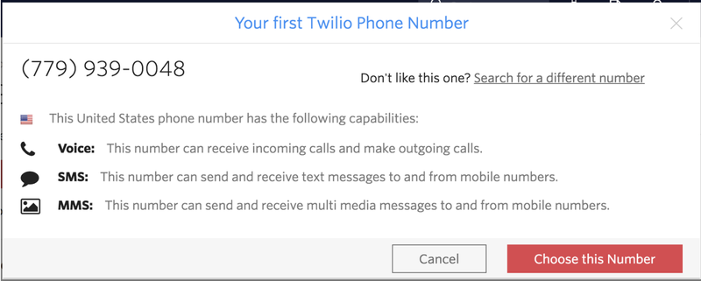

## After you get Twilo Number you should see a screen like this

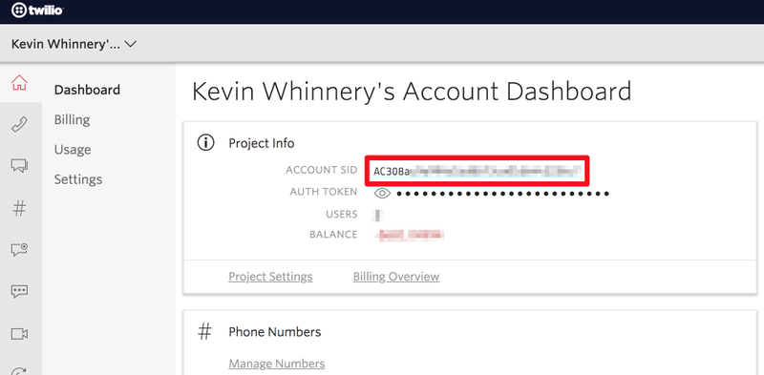

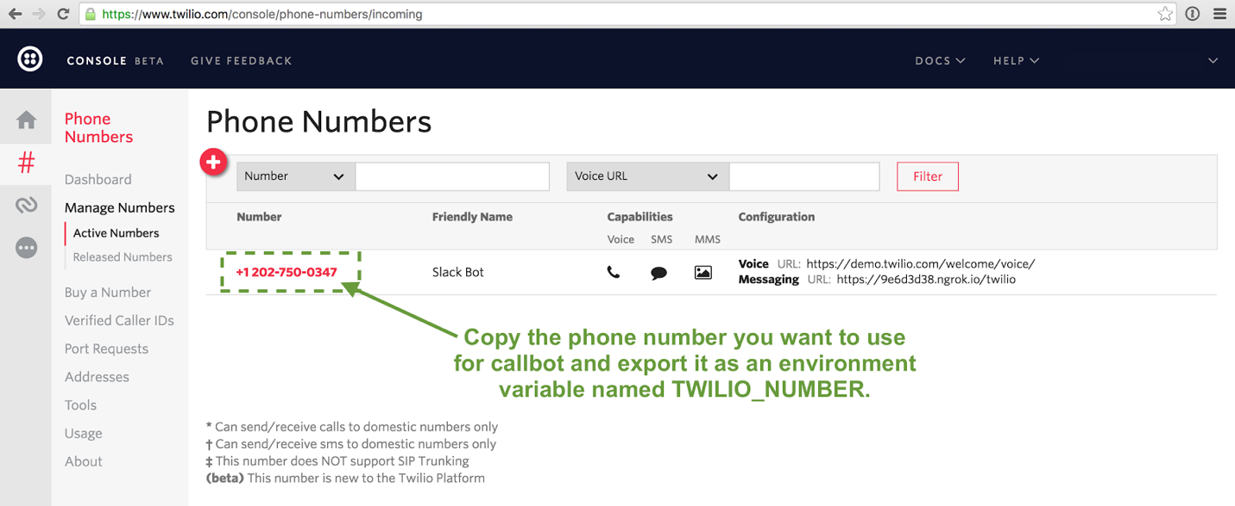

# Step 3: Download Python Library for Twilio

pip install twilio.rest if pip install didnt work for you go ahead to google and and read the doccumentaion on downloading TWILIO for Python 3 +

# Step 4 : Lets Code .........

### Import the library

from twilio.rest import Client

### Define a Function to send SMS

Make sure to use try and except Block to Avoid Errors Add you SSID and AUTH Token.

# def send_sms_alert():

# try:

# # Define your body

# my_body='Yo'

# # define client

# client = Client('SSID GOES HERE XXX ','AUTH TOKEN XX ')

# client.messages.create(to='+ TO XXXX ',

# from_= '+TWILIO NUMBER XXX',

# body=my_body)

# except:

# print('Cannot send Sms!')

### Putting all Together

# from twilio.rest import Client

# def send_sms_alert():

# try:

# # Define your body

# my_body='Yo'

# # define client

# client = Client('SSID GOES HERE XXX ','AUTH TOKEN XX ')

# client.messages.create(to='+ TO XXXX ',

# from_= '+TWILIO NUMBER XXX',

# body=my_body)

# except:

# print('Cannot send Sms!')

# send_sms_alert()

If you have Error make sure you have entered correct SSID and AUTH key. After that Make sure you have entered correct Phone Number Make sure to senter your number in to as we are suing Trial Account wont be able to send sms to other people as its a premuim Features.

## **Congrulations You just sent a SMS using Python**[¶](http://localhost:8888/notebooks/Desktop/Important%20Documents%20/IoT%20final/Combined/Lab%204/Lab%204A%20(Twilio).ipynb#Congrulations-You-just-sent-a-SMS-using-Python)

# Practical Example





# Please follow complete Steps on how to install the Library on following link

Installation Steps: -

Python library to read the DHT series of humidity and temperature sensors on a Raspberry Pi or Beaglebone Black. Designed specifically to work with the Adafruit DHT series sensors ----> <https://www.adafruit.com/products/385> Currently the library is tested with Python 2.6, 2.7, 3.3 and 3.4. It should work with Python greater than 3.4, too Dependencies

For all platforms (Raspberry Pi and Beaglebone Black) make sure your system is able to compile and download Python extensions with pip:

On Raspbian or Beaglebone Black's Debian/Ubuntu image you can ensure your system is ready by running one or two of the following sets of commands

Python 2: sudo apt-get update sudo apt-get install python-pip sudo python -m pip install --upgrade pip setuptools wheel

Python 3: sudo apt-get update sudo apt-get install python3-pip sudo python3 -m pip install --upgrade pip setuptools wheel

Install with pip Use pip to install from PyPI.

Python 2: sudo pip install Adafruit_DHT

Python 3: sudo pip3 install Adafruit_DHT

Compile and install from the repository First download the library source code from the GitHub releases page, unzipping the archive, and execute: Python 2: cd Adafruit_Python_DHT sudo python setup.py install

Python 3: cd Adafruit_Python_DHT sudo python3 setup.py install

You may also git clone the repository if you want to test an unreleased version: git clone <https://github.com/adafruit/Adafruit_Python_DHT.git>

import Adafruit_DHT

from twilio.rest import Client

pin = 4

sensor = Adafruit_DHT.DHT22

def main():

humidity, temperature = Adafruit_DHT.read_retry(sensor, pin)

if humidity is not None and temperature is not None:

print('Temp={0:0.1f}*C Humidity={1:0.1f}%'.format(temperature, humidity))

if humidity >34:

print("Alert ")

send_sms_alert(' High Temperature Alert Warning ')

else:

print('Failed to get reading. Try again!')

def send_sms_alert(text='Python'):

try:

# Define your body

my_body = text

# define client

client = Client('SSID GOES HERE XXX ','AUTH TOKEN XX ')

client.messages.create(to='+ TO XXXX ',

from_= '+TWILIO NUMBER XXX',

body=my_body)

except:

print('Cannot send Sms!')

if __name__ == "__main__":

while True:

main()

Application

Here is an example where I used Twilio

<https://www.youtube.com/watch?v=hT4zp-mGFkE>

<https://www.youtube.com/watch?v=lrSUts2hNlw>

Getting started with IFTTT Lab 4B

# Objective:

our goal is to learn the Most popular Cloud services that is IFTTT. IFTTT stands for if this than that. it provides lot of services from Phone, SMS, Gmail , Drive and much more possibilities are endless. it also allows you to connect your IoT device get and notidfied when an event occurs through webhook.

### **Step 1: Create a Account on IFTTT**

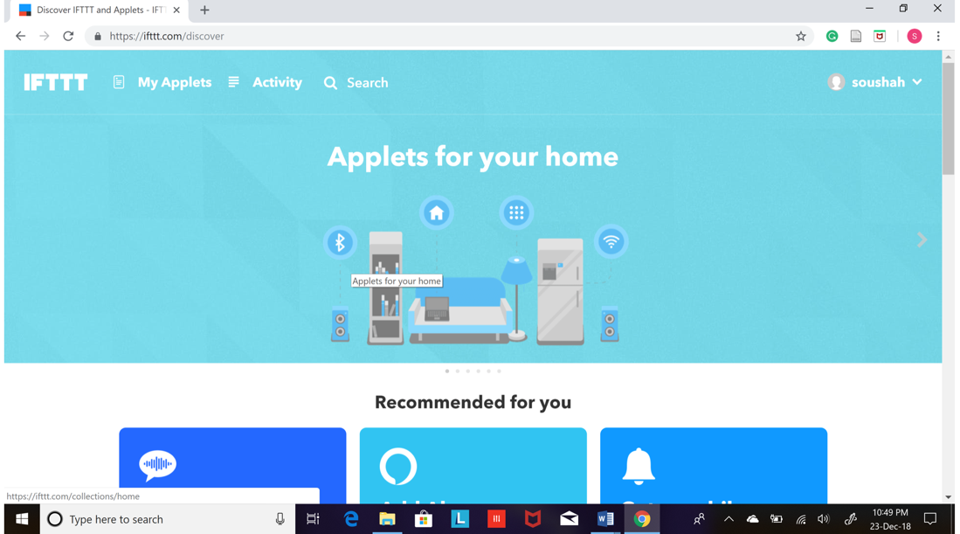

once you create a accout you should see a screen something like this

### **Step 2: Search for WebHook on Search Bar**

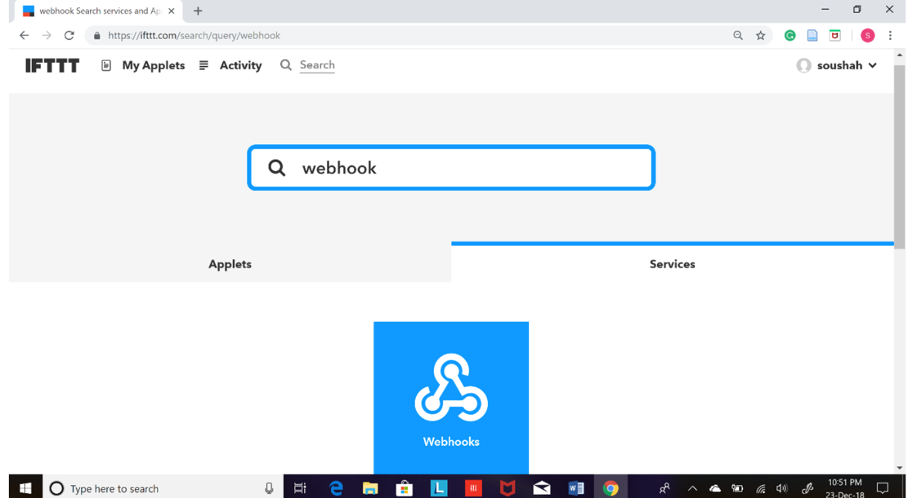

### Step 3: Click on Documentation

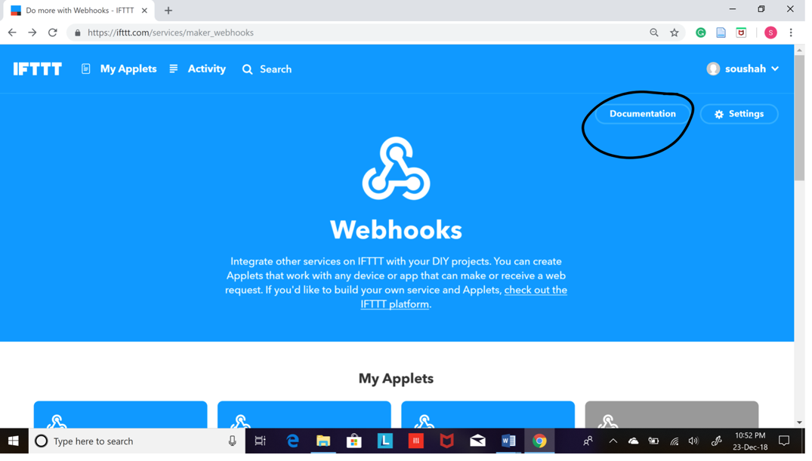

### Step 4: Copy the Secret Key

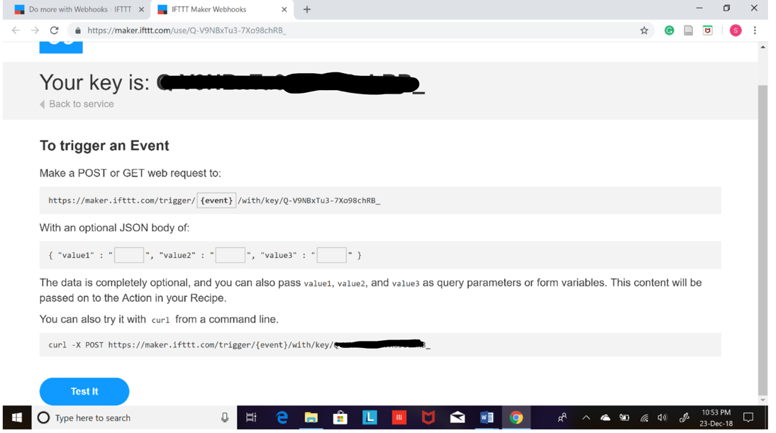

### Step 5: create a New Applete

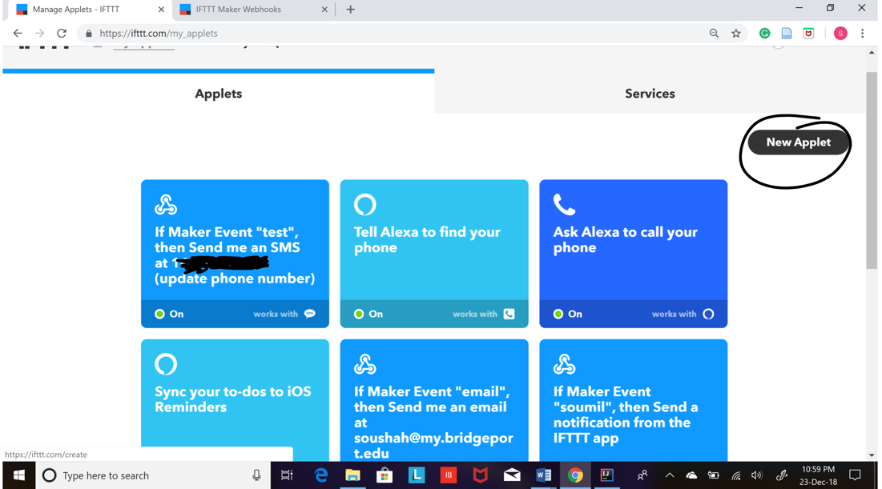

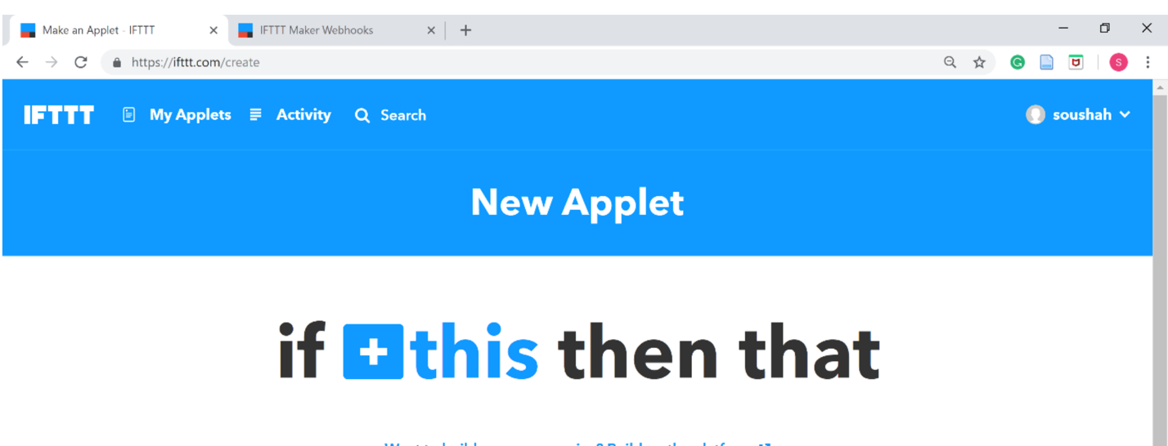

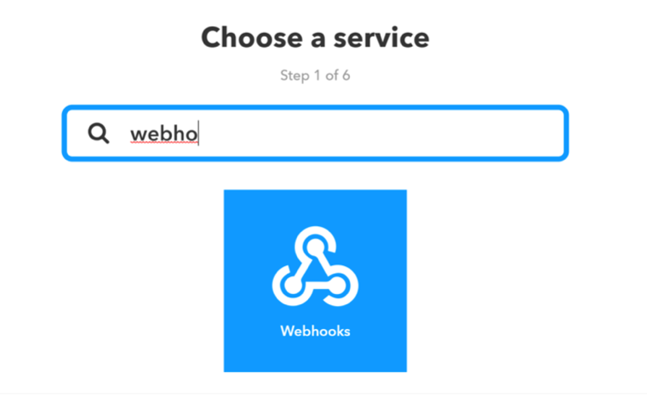

Choose receive web requests option form menu

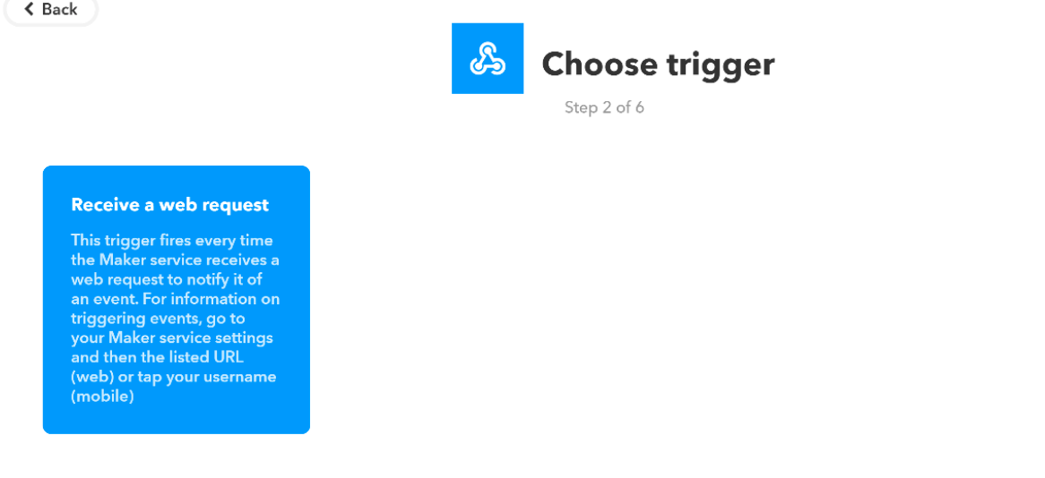

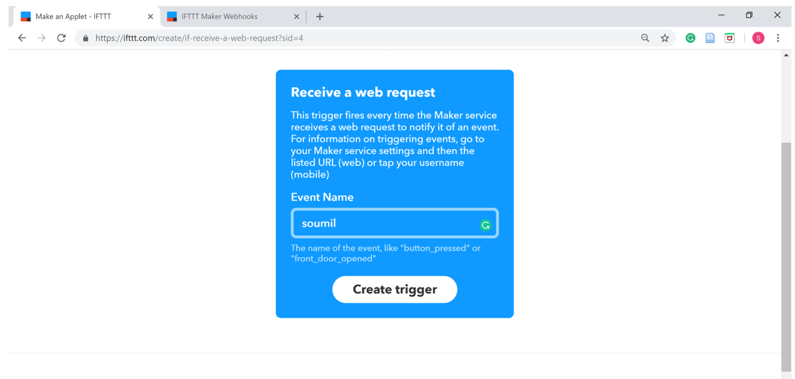

Create Trigger

Note:- Use the IoT Master Library which was discussed above

Code:

#iftt_k = 'Q-XXXXXX-7Xo98chRB_'  
#feed = 'sensor'  
  
#ob1 = IfTTT(eventname=feed, key=iftt_k)  
#ob1.iftt_post(data1=temperature,data2=humidity)

Lab V

Lab 5 Node-Red

**OBJECTIVE:**

Learn how to use Node-RED to communicate with the Raspberry Pi’s GPIO pins. You will create a Node-RED ‘flow’ to control LEDs, Log weather data to Evernote on button press, Send ultrasonic sensor data to mobile as a SMS.

## COMPONENTS:

1) RPi 3

2) Breadboard

3) 330 Ω Resistor x 1

4) Push Button x 1

5) LED x 1

6) HC-SR04 Ultrasonic Distance Sensor x 1

7) Connecting Wires

## Node-RED:

Node-RED is a flow-based programming tool for wiring together hardware devices, APIs and online services in new and interesting ways. Developed by IBM Emerging Technology and the open source community. It provides a browser-based editor that makes it easy to wire together flows using the wide range of nodes in the palette that can be deployed to its runtime in a single-click. It is built on Node.js. Node Red can be installed on Raspberry Pi and its server can be run on it.

For Raspbian pre-installed with Node-RED, you need to upgrade it. Use the following commands (without ‘$’):

sudo apt-get update

update-nodejs-and-nodered

### **To freshly install Node-Red on your Raspberry Pi:2**[**¶**](http://localhost:8888/notebooks/Desktop/Important%20Documents%20/IoT%20final/Combined/Lab%205/Lab%205.ipynb#To-freshly-install-Node-Red-on-your-Raspberry-Pi:2)

Before installing node red, first install npm and node.js on your raspberry pi. Refer <http://www.instructables.com/id/Install-Nodejs-and-Npm-on-Raspberry-Pi/>For Node Red, refer <https://nodered.org/docs/hardware/raspberrypi>. Type the given commands in your terminal.

Open Node Red by typing node-red-start in your terminal, or by (Figure 23):

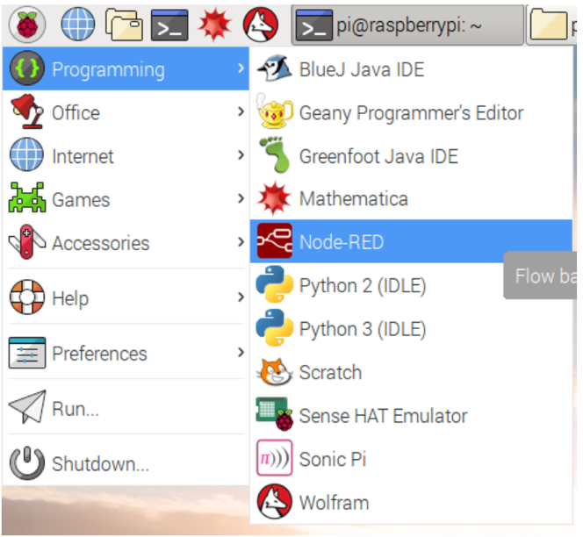

### Ultrasonic Sensor:

HC-SR04 is a commonly used module for non-contact distance measurement for distances from 2cm to 400cm. This sensor uses ultrasonic sound to measure distance just like bats and dolphins do. Ultrasonic sound has such a high pitch that humans cannot hear it. This particular sensor sends out an ultrasonic sound that has a frequency of about 40 kHz. The sensor has two main parts: a transducer that creates an ultrasonic sound and another that listens for its echo. The time difference between transmission and reception of ultrasonic signals is calculated. Using the speed of sound and ‘Speed = Distance/Time' equation, the distance between the source and target can be easily calculated.

Distance Calculation: Distance = Speed * Time/2

The "2" is in the formula because the sound has to travel back and forth. First the sound travels away from the sensor, and then it bounces off of a surface and returns back. we need only half of this. Therefore time is taken as time/2. Speed of sound at sea level = 340 m/s

### Thus, Distance = 17150 * Time (unit cm)

### Module 1: Use Node-RED to control LED via the Raspberry Pi’s GPIO pins

## CIRCUIT DIAGRAM:

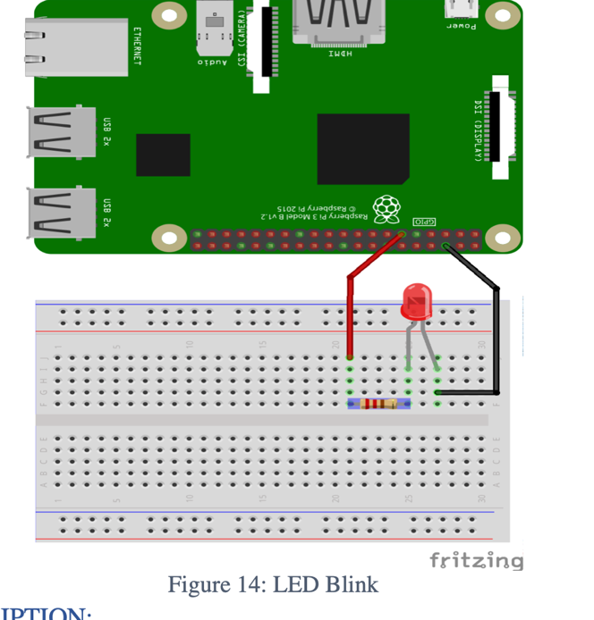

### CIRCUIT DESCRIPTION

1. BCM PIN CONFIGURATION IS USED.
2. Positive leg of LED to one end of resistor.
3. Other leg of resistor to GPIO 17
4. Negative leg of LED to Ground pin

### CREATING THE PROGRAM:

1. Start up your Raspberry Pi. Click on the Raspberry icon, then the Programming menu to open Node-RED (Figure 23) You should see a window displaying information about Node-RED starting up

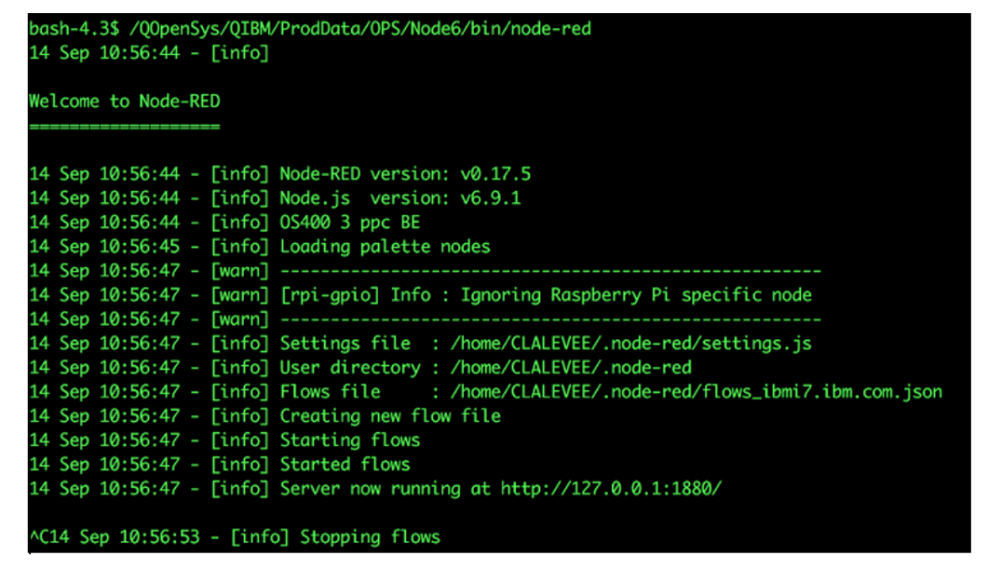

1. Now go to the Internet menu and open Chromium Web Browser. If chromium is not installed, type $ sudo apt-get install chromium-browser --yes in your terminal.
2. In Chromium, locate the address bar at the top and type in localhost:1880, then press Enter. This will display the Node-RED interface. (Your Raspberry Pi does not need to be connected to the internet to use Node-RED: localhost is the address the Raspberry Pi uses to refer to itself and :1880 means that it is looking at port 1880.)

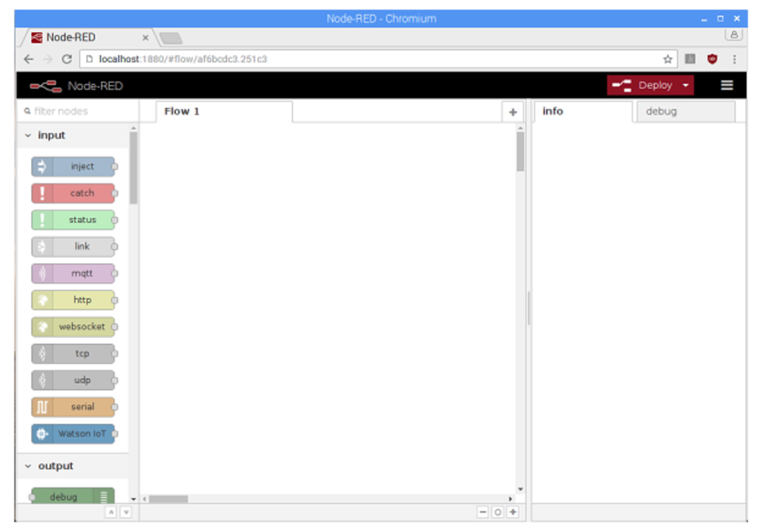

1. Programs in Node-RED are called flows. You can see that your blank page is labelled as Flow 1 in the tab at the top. You can create as many flows as you want and they can all run at the same

The coloured blocks on the left side of the interface are the nodes. Scroll right down to the bottom of the list and you will see some nodes labelled Raspberry Pi.

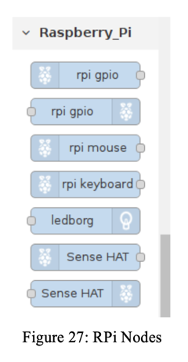

1. You will see two nodes with the label rpi gpio: these are the ones we will use to talk to the GPIO pins on the Raspberry Pi. The first one in the list, with the raspberry icon on the left, is for inputs. Using a button push to control something would be an example of an input. The second node, with the raspberry icon on the right, is for outputs. Switching on an LED would be an example of an output. Drag an output node onto the blank page in the middle.

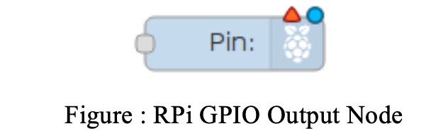

1. Double-click on the node and a box will appear to let you configure the node. Change the GPIO pin to be GPIO17 and tick Initialise pin state?. Leave the setting for Initial level of pin on low. Give the node a name. When you are finished, click Done

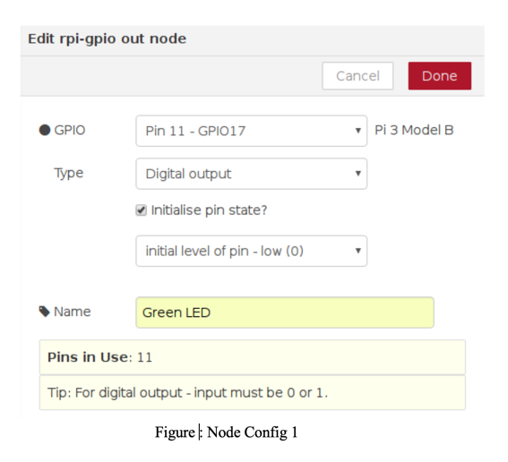

1. Now scroll back up to the list of nodes. To turn the LED on and off, we need an input. In Node-RED we can inject messages into the flow and cause things to happen as a result. Drag an inject node onto the flow

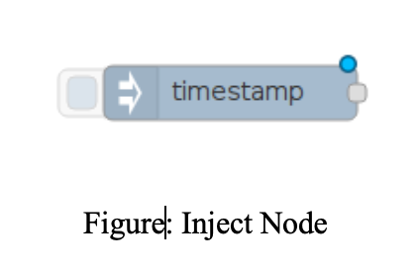

1. Double-click on the inject node. Use the drop down next to Payload to change the data type to string and type 1 in the Payload box - this will be the message. Type On in the Name box. Press Done

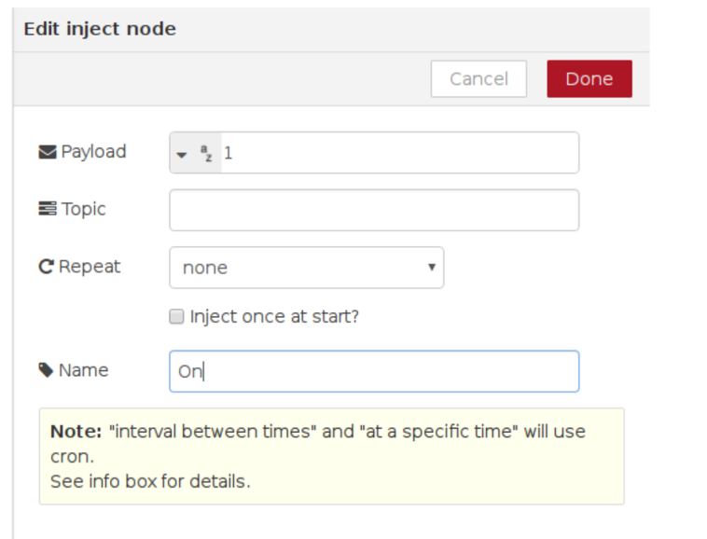

1. Repeat the previous steps to create another inject node, except this time add 0 as the payload message, and call this node Off.and call this node Off.
2. Now look for the grey dot on the right side of the inject nodes. Click and drag from the grey dot on the On node to the grey dot on your LED node to join them up. Repeat for the Off node, also joining it to the LED node.

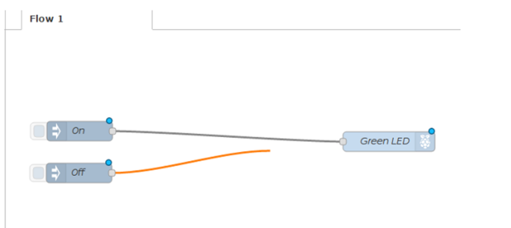

1. Our flow is finished, so we can deploy it. Click on the big red Deploy button on the top right of the screen. A message should pop up at the top saying “Successfully deployed”. This is similar to pressing the green flag in Scratch or F5 to run your code in Python.

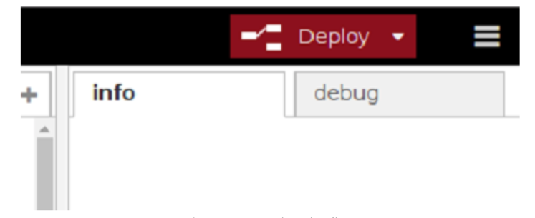

1. Now click on the blue square on the left of the On node to inject the message 1. The Green LED node receives the message and your LED should light up. You should be able to turn the LED off by clicking the blue square on the Off node, which injects the message 0.

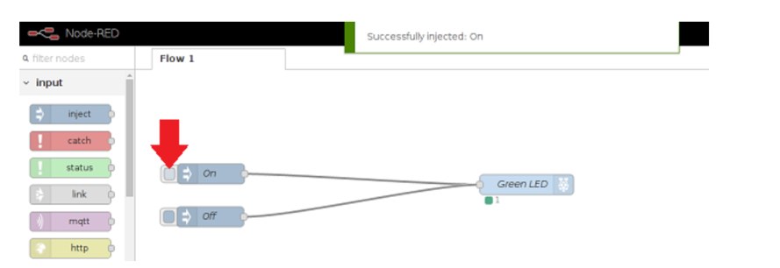

1. You can also ask Node-RED to display debugging information by wiring up your nodes to a Debug node, which can be found under output. Drag in a debug node and wire your two inject nodes to it, then click Deploy. When you click the buttons to inject the message, Node-RED will show you what was injected in the Debug tab on the right side of the screen. Click the tab to display the messages

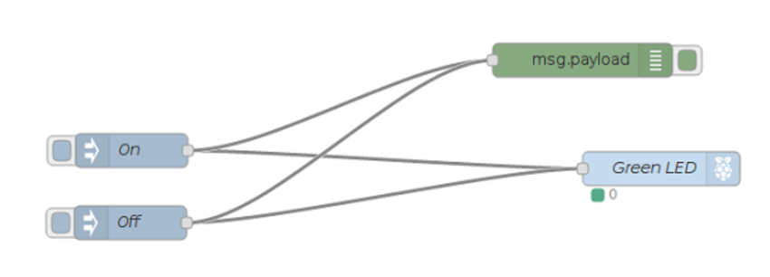

For example, this is the output if you click first on the On node and then on the Off node.

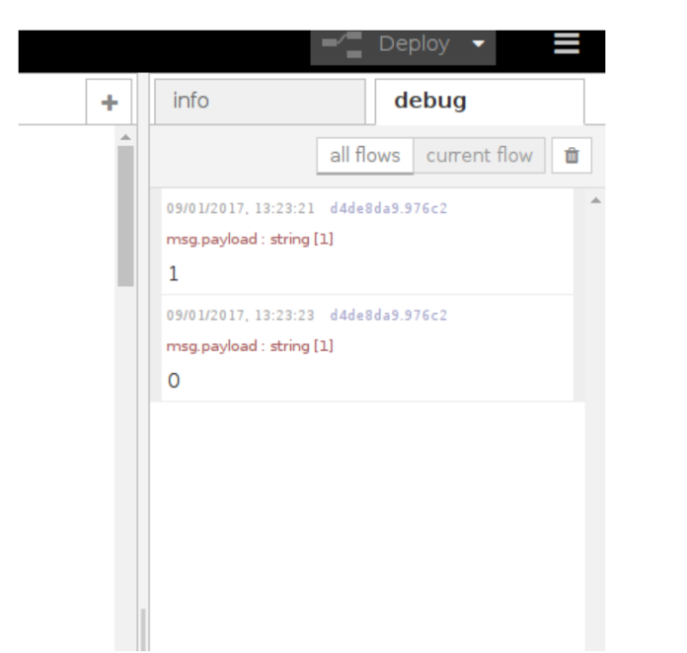

Lab 5A:

# **Objective:**[**¶**](http://localhost:8888/notebooks/Desktop/Important%20Documents%20/IoT%20final/Combined/Lab%205/Lab%205A.ipynb#Objective:)

Adding a Button or input Device learn to interface using Node-red

### CIRCUIT DIAGRAM:

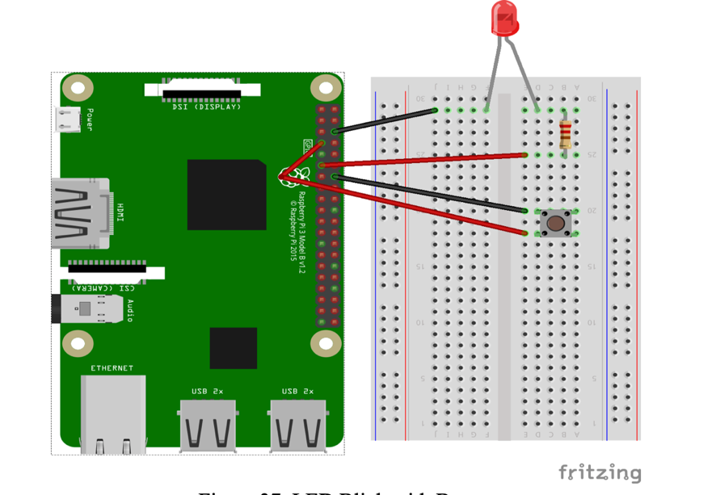

### CREATING THE PROGRAM:

1. Now let’s add a button to control the LED. Wire up your button to the Raspberry Pi as shown in Figure 37, so that your LED is still connected to GPIO pin 17, and your button is connected to GPIO pin 4
2. Remove your Turn on and Turn off inject nodes by clicking the node and pressing Delete on the keyboard. We no longer need these, as we will be controlling the LED using a physical button.
3. Now we need to add a Raspberry Pi GPIO input node. This is the node with the raspberry icon on the left. Set up this node to receive input from your physical button as follows:

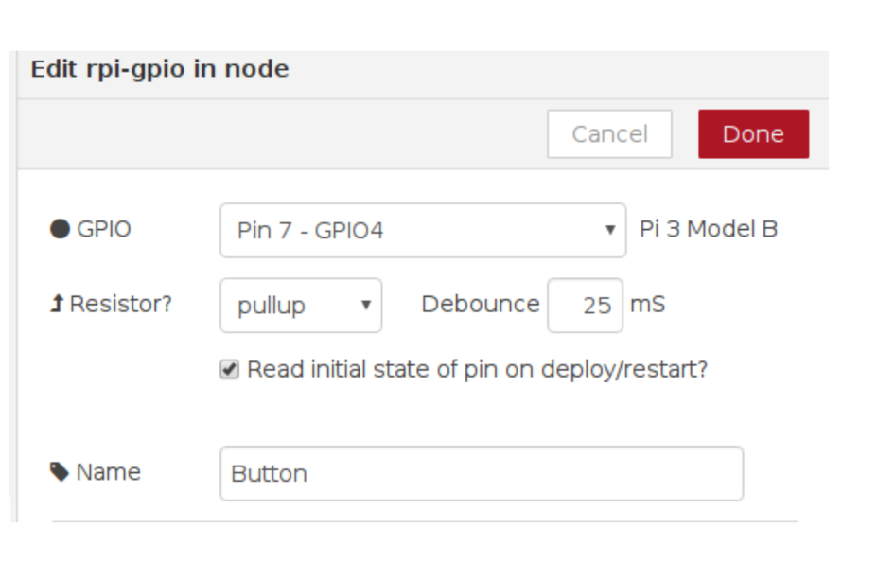

Specifying pullup means that GPIO pin 4 will be set to HIGH, and pressing the button will cause it to go LOW.

1. Now join up your button node output to the existing debug and LED nodes. Deploy the flow and test it by pressing the button.

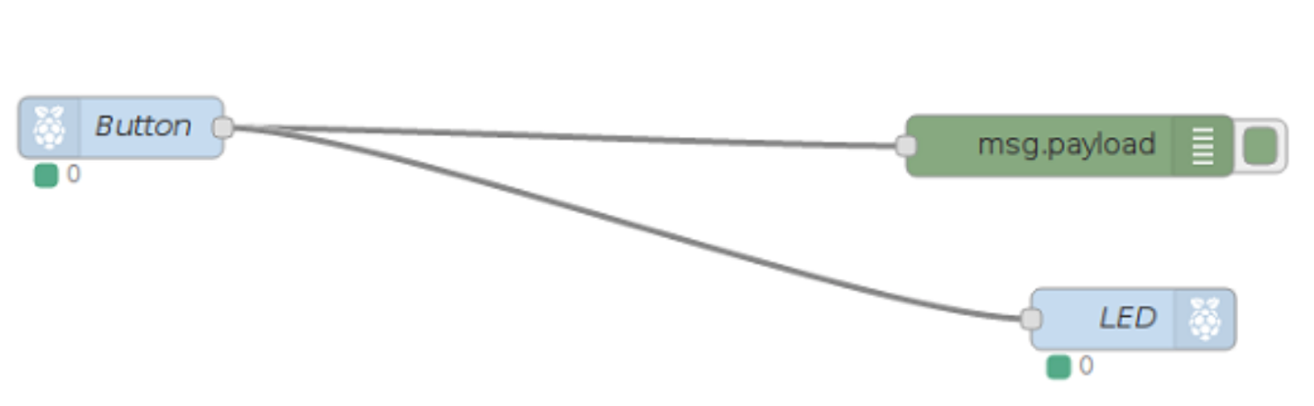

You will notice that the LED is lit to start with, and that pressing the button switches it off. That’s not quite right! This is because we are using pullup as explained in the previous step, so the button pin will be HIGH by default. HIGH generates the message 1, and this turns the LED on. When we press the button, we cause the pin to go LOW, generating a 0 message which turns off the LED. We need to reverse the values. We want the LED to receive the message 0 by default and the message 1 when the button is pressed.

1. Remove the connection you made between the button node and the LED node by clicking on the line and pressing Delete on the keyboard.
2. Add a switch node. This can be found in the function section. This node is similar to the if/elif/else type constructs you may have seen in Scratch or Python. You can configure it to have multiple output paths (outlined in red on the screenshot) depending on the value passed in. In this case we will set up the node so that if the property msg.payload is equal to 1, the first path will be followed. Click the small Add button at the bottom to add a second path, and for this path select otherwise in the drop down. This path will be followed if the input was anything other than 1. Click Done when you are finished.



1. You should see your newly created switch node, with two dots on the right side for outputs. Note that the title If input is 1 is simply a description of what the node does, and has no effect on its function.
2. Join up the GPIO input button node to the input (left side) of the switch node
3. Now drag in a yellow change node from the functions section and double-click on it to configure it. We will use this node to change the message being sent. Remember: when we created the switch node, the first output was set to be followed if the input message was 1. We will use the change node to change the message to 0.

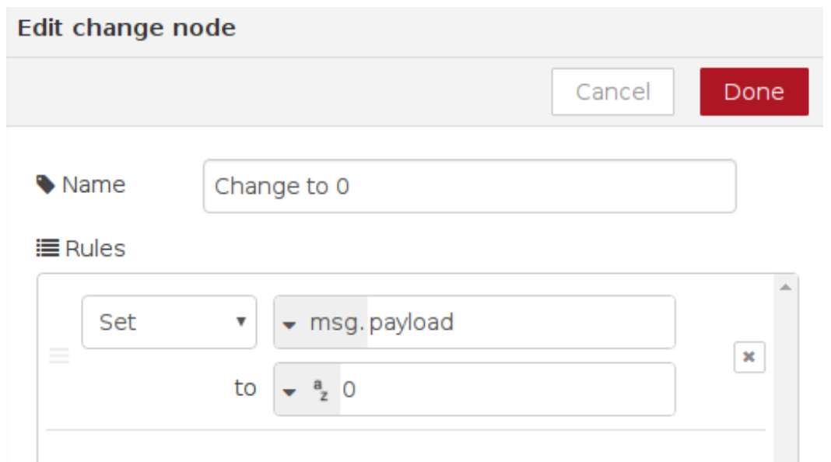

1. Press Done, then draw a line from first output of the switch node to the change node. Then connect the output of the change node to the LED node:
2. Now add another change node to set the msg.payload to 1. Connect this node to output 2 of the switch node and then to the LED node. This tells the flow that when the otherwise branch is followed (i.e. the msg.payload is not already 1), we would like to change it to 1. When you are ready, deploy your flow, and then push the physical button to confirm that it works properly

### Final Diagram

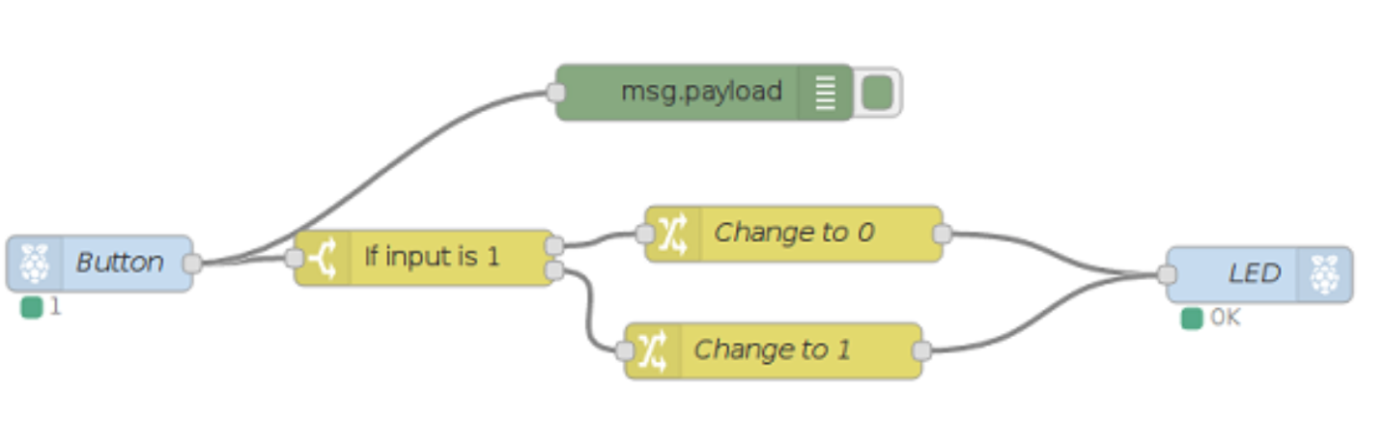

Lab VI

Lab 6:- **DATA LOGGER**

## OBJECTIVE:[¶](http://localhost:8888/notebooks/Desktop/Important%20Documents%20/IoT%20final/Combined/Lab%206/Lab%206%20(FData%20Logger).ipynb#OBJECTIVE:)

This simple data logger takes regular light measurements with an analogue LDR (Photoresistor) and stores them in a text file on your Raspberry Pi. This data logger will measure and record the light level every second, enabling you to monitor how the brightness changes over a length of time. Later we send the data to ThingSpeak cloud platform and visualize the data.

## **COMPONENTS:**

1) RPi 3

2) Breadboard

3) Photoresistor x 1

4) 1µF Capacitor

5) Connecting Wires

## **Light Dependent Resistor:**

The light dependent resistor or also known as the LDR sensor is the most important piece of equipment in our circuit . Without it we wouldn’t able to detect whether it is dark or light. In the light this sensor will have a resistance of only a few hundred ohms whilst in the dark it can have a resistance of several megohms.

resistance of several megohms. The capacitor in our circuit is there so we’re able to measure the resistance of the LDR sensor. A capacitor essentially acts like a battery charging up whilst receiving power and then discharging when no longer receiving power. Using this in series with the LDR we can work out how much resistance the LDR is giving out thus whether it is light or dark.

If we want to use analogue sensors with the Raspberry Pi, we would need to be able to measure the resistance of the sensor. Unlike the Arduino, the Raspberry Pi's GPIO pins are unable to measure resistance and can only sense if the voltage supplied to them is above a certain voltage (approximately 2 volts). To overcome this issue, you could use an Analogue to Digital Converter (ADC), or you could use a relatively cheap capacitor instead.

## **CIRCUIT DIAGRAM:**

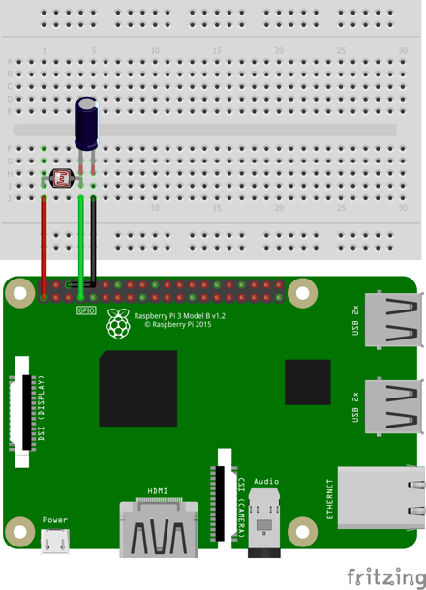

### **CIRCUIT DESCRIPTION:**[**¶**](http://localhost:8888/notebooks/Desktop/Important%20Documents%20/IoT%20final/Combined/Lab%206/Lab%206%20(FData%20Logger).ipynb#CIRCUIT-DESCRIPTION:)

1. BOARD PIN CONFIGURATION IS USED.
2. One end of LDR to 3.3v pin.
3. Other end of LDR to pin #7.
4. One end of Capacitor is connected to LDR.
5. Other end of capacitor to Ground ping

### **CREATING THE PROGRAM:**

1. Go to TERMINAL
2. Navigate to workspace folder (created in lab 1) by typing the command: $ cd workspace
3. Open this folder in your file system
4. Right click the mouse and choose new file and name it as lab3.py
5. Right click on the file and open with IDLE3. Make it default program.
6. Type the below code and save the file.
7. Go to terminal and run the program with the below command:

$ python lab5.py

Code: -

#Data logger stored on RPi

import RPi.GPIO as GPIO

import time

import datetime

ldr_pin = 7

log_interval = 1 #in seconds

file_name = "data_logger.txt"

open(file_name, 'w').close()

GPIO.setmode(GPIO.BOARD)

def loop():

while True:

for x in range (1, 6):

if x == 5:

ldr = recharge_time(ldr_pin) #call recharge time method

print(ldr)

data_to_write = (str(datetime.datetime.now()) + " , " + str(ldr)) #format data to write

write_to_file(data_to_write, file_name) #call write to file method

time.sleep(log_interval)

def recharge_time(ldr_pin):

count = 0 #initialize counter to zero

GPIO.setup(ldr_pin, GPIO.OUT) #initially set it to Output

GPIO.output(ldr_pin, GPIO.LOW)

time.sleep(0.1)

GPIO.setup(ldr_pin, GPIO.IN) #change the pin back to input

while (GPIO.input(ldr_pin) == GPIO.LOW): #count until the pin goes high

count += 1

return count

def write_to_file(text, file):

f = open(file,'a') #open file with append option

f.write(text+'\n')

f.close()

if __name__ == '__main__':

try:

loop()

except KeyboardInterrupt:

GPIO.cleanup()

### EXPLANATION:

With reference to the above code:

Run the above code and see your terminal. You can see the count printed on the console (Figure 47). It is updated every second. Count value accumulates for the time ldr pin is LOW. Higher the light intensity, lower the count value and vice versa. Open "data_logger.txt" which is your workspace folder. You can see data being logged with its respective timestamp (Figure 48).

